**Cheniston Statement of Significance, May 2021**

|  |  |
| --- | --- |
| **Heritage place:** Cheniston, 20 Cheniston Road, Mount Macedon | **PS ref no.:** HO328 |

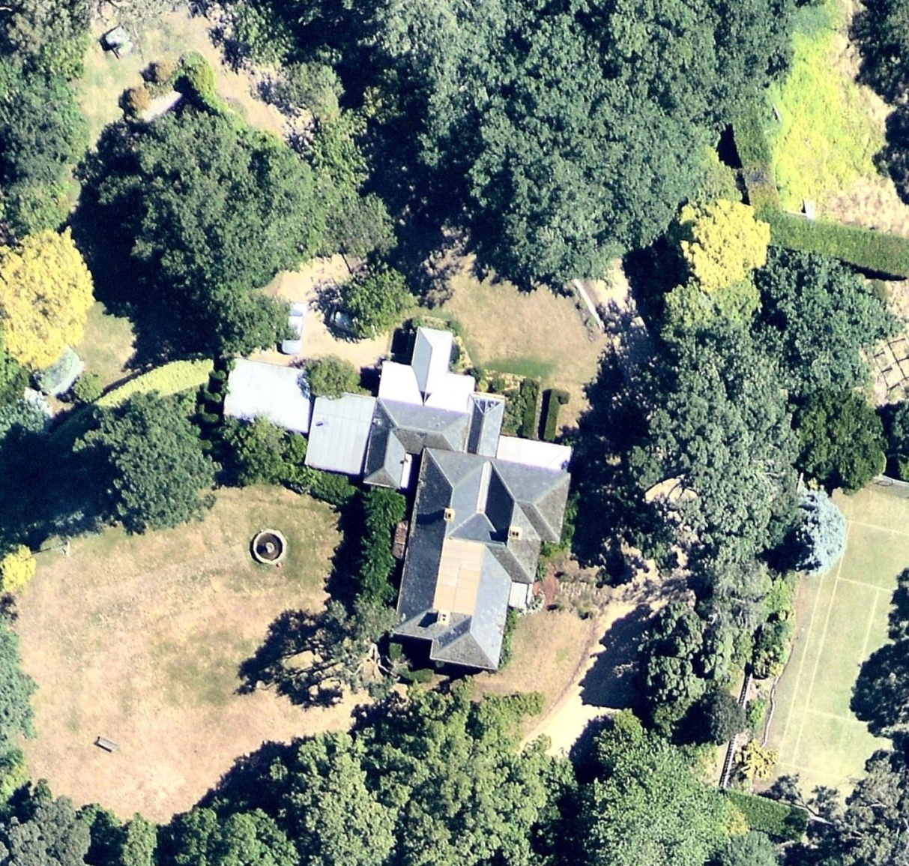

Figure 1. 20 Cheniston Road, Mount Macedon (Aerial photo dated Jan 2018. Source: Nearmap)

***What is significant?***

Cheniston, 20 Cheniston Road, Mount Macedon, a hill station established in the late 1880s and including a late Victorian house.

Elements that contribute to the significance of the place include (but are not limited to):

* The external form, materials and detailing of the house
* The house’s high level of integrity to its original design
* Early outbuildings

*Description*

The outbuildings include a detached stables, coachhouse, gardener’s cottage and motor-house.

* Gardens, including mature plantings.

*Description*

The mature garden includes oaks, weeping elms and Douglas firs.

Recent alterations and additions to the 1889-90 residence are not significant.

***How is it significant?***

Cheniston is of local historical, architectural and aesthetic significance to the Shire of Macedon Ranges.

***Why is it significant?***

Cheniston has strong associations with the establishment of hill stations at Mount Macedon by prominent and wealthy Victorians from the 1870s. The place clearly illustrates the initial establishment, and the subsequent development, of the mountain as a summer retreat comprising large garden estates with substantial houses set in extensive grounds (Criterion A).

Cheniston is a representative example of a hill station established at the mountain location from the late 1880s. It displays typical features of this place type, including extensive grounds, a large, prominent house, outbuildings and a collection of mature trees and other plantings (Criterion D).

Cheniston is a highly developed picturesque hill station. Extensive grounds, containing a prominently-sited house and mature plantings present a picturesque composition (Criterion E).

*Summary*

Cheniston, Mount Macedon is of note as a fine and representative example of a Mount Macedon hill station. Cheniston appears to retain its extensive grounds, late Victorian house, outbuildings and garden which includes mature trees and other plantings. Despite modifications to both the buildings and garden, the place has clear associations with the important hill station class of place.

**Image**



Figure 2. An early photo of ‘Cheniston’; no date to photo (Boyd & Boyd, 2009: 60).

**Aerial**

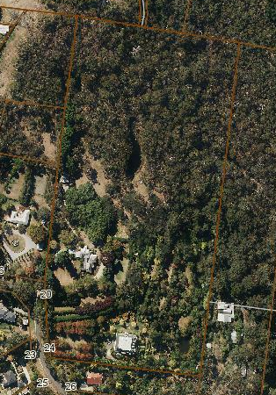

Figure 3. Aerial photo of 20 Cheniston Road, Mount Macedon (Source: Macedon Ranges Shire Council, aerial dated March 2018).

**Primary source:**

*Macedon Ranges Shire Heritage Study: Woodend, Lancefield, Macedon & Mount Macedon Stage 2 Final Report Volumes 1 and 2* (GJM Heritage and Frontier Heritage, April 2019)