**Carramar Statement of Significance, May 2021**

|  |  |
| --- | --- |
| **Heritage place:** Carramar, 20 Bowen Street, Woodend | **PS ref no.:** HO337 |

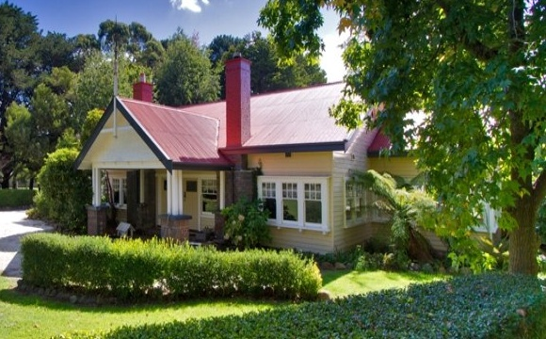

Figure 1. 20 Bowen Street, Woodend (Photo dated 2012.  
Source: <https://www.realestate.com.au/sold/property-house-vic-woodend-110305505>)

***What is significant?***

Carramar, 20 Bowen Street, Woodend, a house built in 1924 and designed by architects Haddon & Henderson.

Elements that contribute to the significance of the place include (but are not limited to):

* The house’s original form, materials and detailing
* The house’s high level of integrity to its original design
* The original garage

*Description*

To the north of the house there are several outbuildings, which includes the original garage.

* The mature trees and established garden surrounding the residence.

*Description*

The house is sited near central on the property and is largely concealed from the street by a densely planted, mainly exotic, landscape that appears to be contemporary to the house. The building is orientated with the principal façade and entrance facing south with a formal hedged lawn area in front. The original access to the site is likely to have been from the south-west corner gate via a winding gravel drive lined with mature trees.

* The historic driveway alignment from the south-west of the site.

Later additions and alterations are not significant.

***How is it significant?***

Carramar is of local historical, architectural and aesthetic significance to the Shire of Macedon Ranges

***Why is it significant?***

Carramar is illustrative of residential development which occurred in rural townships in the inter-war years of the twentieth century and has associations with the establishment of easily accessible summer residences by wealthy Victorians (Criterion A).

Carramar is a fine and highly intact example of an Inter-war Bungalow house which embraces the outdoors-orientated design of the period. It displays typical features of a house of the 1920s in Woodend and across Victoria more broadly, including long, low house lines, asymmetrical massing, wide spreading roofs, broad eaves, ample windows with projecting window frames, a large porch and typically timber construction (Criterion D).

Carramar is a well-considered and carefully detailed example of an Inter-war Bungalow house. The timber house, with main roof form and prominent front gable, tall chimneys, abundant glazing with multi-paned sashes and an expansive garden setting, presents as a picturesque composition of this architectural style (Criterion E).

Carramar is significant as one of a small number of residential buildings that can be attributed to Robert Haddon who was a prominent and highly influential Melbourne architect, architectural writer and educator from the early twentieth century until his death in 1929. Haddon was well known and widely recognised for the application of strong architectural principles in his design work and these are evident at Carramar (Criterion H).

*Summary*

Carramar, Woodend is of note as a well-considered and finely detailed intact example of a substantial inter-war house built in a rural township. Designed by prominent Melbourne architects Haddon and Henderson, the timber house has a bungalow appearance in an expansive garden setting.

**Image**



Figure 2. Haddon’s illustration of house and garage at the subject site, annotated ‘New Country Bungalow at Woodend for Kenneth Harper Esq.’ (*Australian Home Builder*, 15 Dec 1924:62).

**Aerial**

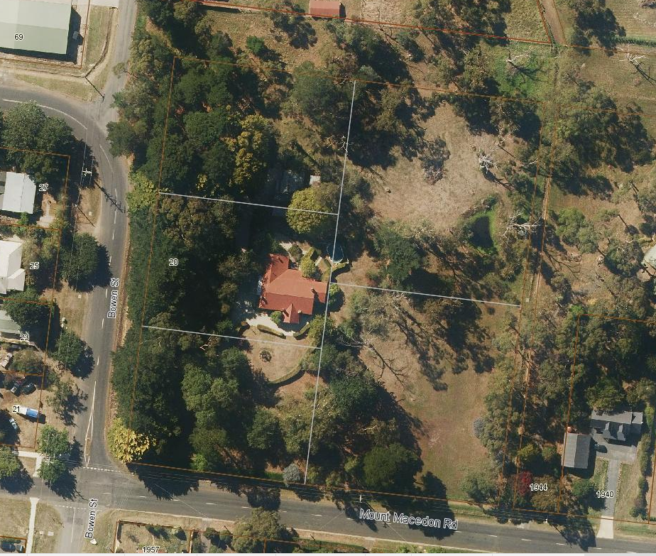

Figure 3. Aerial photo of 20 Bowen Street, Woodend (Source: Macedon Ranges Shire Council, aerial dated March 2018).

**Primary source:**

*Macedon Ranges Shire Heritage Study: Woodend, Lancefield, Macedon & Mount Macedon Stage 2 Final Report Volumes 1 and 2* (GJM Heritage and Frontier Heritage, April 2019)