**Campaspe House Statement of Significance, May 2021**

|  |  |
| --- | --- |
| **Heritage place:** Campaspe House, 29 Goldies Lane, Woodend | **PS ref no.:** HO347 |

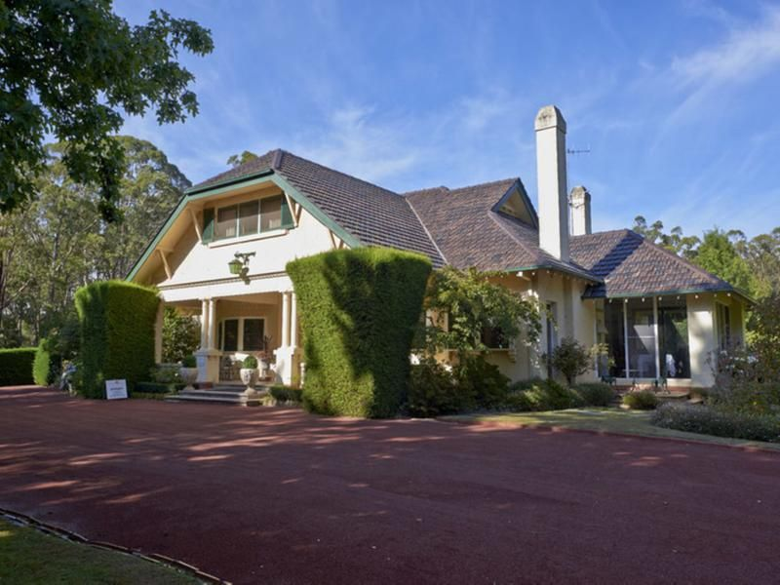

Figure 1. 29 Goldies Lane, Woodend (Photo dated Nov 2017).   
Source: <https://www.domain.com.au/property-profile/29-goldies-lane-woodend-vic-3442>)

***What is significant?***

Campaspe House, 29 Goldies Lane, Woodend, a house built in 1927 and garden.

Elements that contribute to the significance of the place include (but are not limited to):

* The form, materials and detailing of the house
* The house’s high level of integrity to its original design
* Gardens, including mature trees and plantings.

*Description*

The site of approximately 7 hectares is surrounded by a cypress hedge and planting which includes a *Juniperus sp*. and a liquidamber, maples, evergreen and deciduous oaks, flax, pinoak, and Douglas fir. Around the house yard is a dense stand of native gums. Other planting includes: linden trees, cedars, birches, a tulip tree, dogwoods, *Cryptomeria sp*, variegated hollies, flowering cherries, magnolias, lily of the valley and rhododendrons. There are variegated hollies, rose beds and a viburnum hedge at the entry.

* Remnants of Edna Walling-designed garden

*Description*

The garden was designed by prominent garden designer Edna Walling (Figure 2). Although dated c1925-c1965, the landscape plan probably dates to soon after the completion of the house.

Recent alterations, additions and outbuildings, are not significant.

***How is it significant?***

Campaspe House is of local historical, architectural and aesthetic significance to the Shire of Macedon Ranges.

***Why is it significant?***

Campaspe House is illustrative of residential development which occurred on the outskirts of rural townships in the inter-war years of the twentieth century and is associated with the establishment of summer houses in easily accessible rural townships by wealthy Melburnians (Criterion A).

Campaspe House is a fine, intact and representative example of an Inter-war house. It displays typical features of a house of the 1920s in Woodend and across Victoria more broadly, including informal massing with asymmetrical elevations, a tiled helm and Dutch-hipped roof form with attic and bowed window bays (Criterion D).

Campaspe House is a well-considered and carefully detailed house set in a large mature garden, designed by Edna Walling. The stuccoed brick house, with a variety of roof forms, tall chimneys and exaggerated eave brackets, together with the garden, presents a highly picturesque composition from the Inter-war period (Criterion E).

*Summary*

Campaspe House, Woodend is of note as a well-considered and carefully detailed example of a large Inter-war house and garden in the municipality, displaying a number of features typical of the period and style including a large residence and extensive landscaped grounds.

**Image**



Figure 2. The Edna Walling design for the garden at the subject site. Although dated c1920-c1965, the design probably dates to soon after the construction of the house (Edna Walling Collection, SLV Image H97.270/79).

**Aerials**

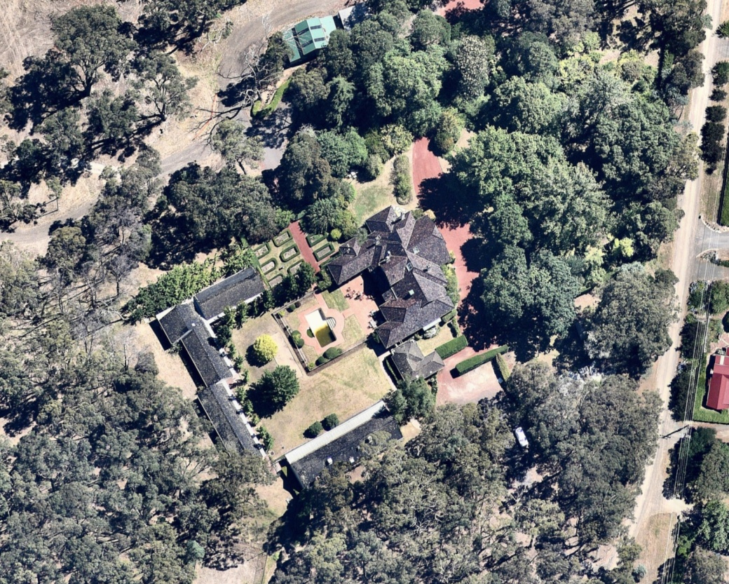

Figure 3. Aerial photo detail of 29 Goldies Lane, Woodend (Source: Nearmap, aerial dated Jan 2018).

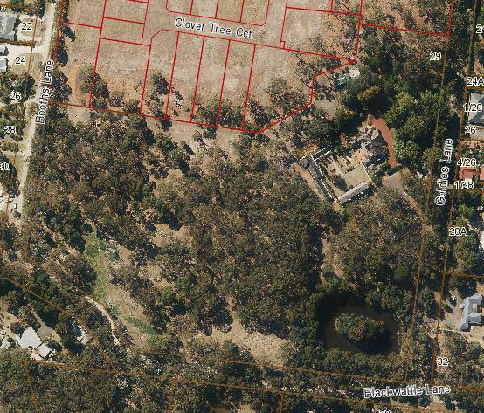

Figure 4. Aerial photo of 29 Goldies Lane, Woodend (Source: Macedon Ranges Shire Council, aerial dated March 2018).

**Primary source:**

*Macedon Ranges Shire Heritage Study: Woodend, Lancefield, Macedon & Mount Macedon Stage 2 Final Report Volumes 1 and 2* (GJM Heritage and Frontier Heritage, April 2019)