**Blois Cottage Farm Complex Statement of Significance, May 2021**

|  |  |
| --- | --- |
| **Heritage place:** Blois Cottage Farm Complex, 114 (part) High Street, Lancefield | **PS ref no.:** HO320 |

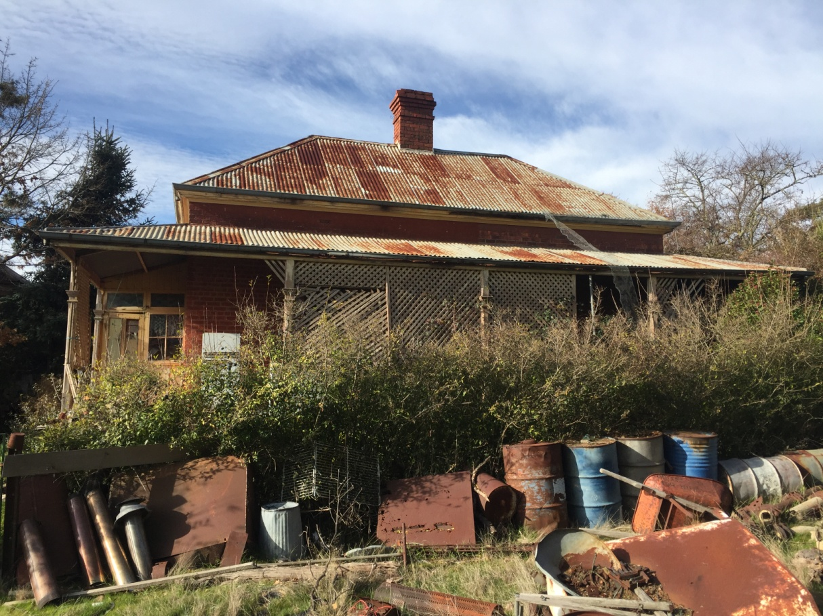

Figure 1. 114 (part) High Street, Lancefield (GJM Heritage/Frontier Heritage, July 2018)

***What is significant?***

Blois Cottage Farm Complex, 114 (part) High Street, Lancefield, a farming property on the edge of the town established in the mid-nineteenth century.

Elements that contribute to the significance of the place include (but are not limited to):

* The farmhouse’s original form, materials and detailing
* The farmhouse’s high level of integrity to its original design
* Early outbuildings, including the church

*Description*

The outbuildings are located to the north east (behind) the house. They are generally timber framed, weatherboard-clad buildings with gable roofs clad in corrugated galvanised iron including a stables building, dairy and storage sheds. The wash house directly behind the kitchen is also of timber framing and cladding and it retains remnants of the original timber shingle roof cladding under the corrugated galvanised iron roof. All of the outbuildings are in a dilapidated state.

To the west of the main house, outside the fenced house garden, is the remains of the former church building that was relocated from the area to this site. The structure is used for storage and it has no floor, only three walls (the east wall has been removed). The structure remains clearly discernible as a former religious building with the pointed arch windows with leadlight and coloured glazing. The timber framed walls are weatherboard clad externally and horizontal timber lining boards internally. The pointed arch windows with wide moulded architraves remain in the three original walls.

* Mature trees and plantings.

*Description*

The almost square site is bordered to the south west and north west by rows of mature trees. There are further mature trees scattered on the site including a number around the house, outbuildings and former Church building in the southern corner of the site.

The property includes an extensive collection of mature trees such a river red gums and other conifers (deodar cedars, cypress) and deciduous trees (pinoaks) including a very large *Arbutus unedo* specimen in the front yard. The house garden includes remnants of lilacs, Pittosporum and holly. Beyond the house garden, to the north west of the house, are the stands of mature trees including a Monterey pine row, ending in a redwood, *Cupressus sempervirens* and other conifers.

Recently constructed outbuildings are not significant.

***How is it significant?***

Blois Cottage Farm Complex is of local historical and architectural significance to the Shire of Macedon Ranges.

***Why is it significant?***

Blois Cottage Farm Complex demonstrates the early establishment of houses on generous allotments on the outskirts of country towns and their subsequent development as farming properties in the rich agricultural district of Lancefield (Criterion A).

Blois Cottage Farm Complex is a fine, intact and representative example of a small nineteenth century farming property. It displays typical features of a farm complex in Lancefield and across Victoria more broadly, including a substantial farmhouse, outbuildings and mature plantings (Criterion D).

*Summary*

Blois Cottage Farm Complex, Lancefield is of note as a representative and intact example of a small nineteenth century farming property in the Shire of Macedon Ranges. The district gained a reputation as a rich agricultural area and properties such as this clearly illustrate this development. It displays a range of characteristics typical of this place type including a single-storey dwelling, a range of associated outbuildings, mature vegetation and a sizable allotment of farming land.

**Image**



Figure 2. Stables (GJM Heritage/Frontier Heritage, July 2018)

**Aerial**

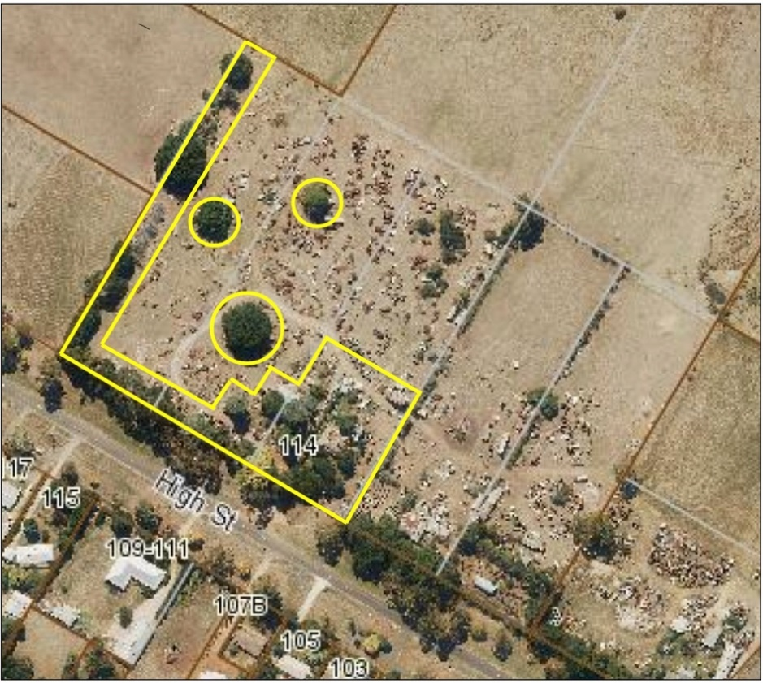

Figure 3. Aerial photo of 114 (part) High Street, Lancefield (Source: Macedon Ranges Shire Council, aerial dated March 2018).

**Primary source:**

*Macedon Ranges Shire Heritage Study: Woodend, Lancefield, Macedon & Mount Macedon Stage 2 Final Report Volumes 1 and 2* (GJM Heritage and Frontier Heritage, April 2019)