**Blanchwood Statement of Significance, May 2021**

|  |  |
| --- | --- |
| **Heritage place:** Blanchwood, 18 Brooke Street, Woodend | **PS ref no.:** HO339 |

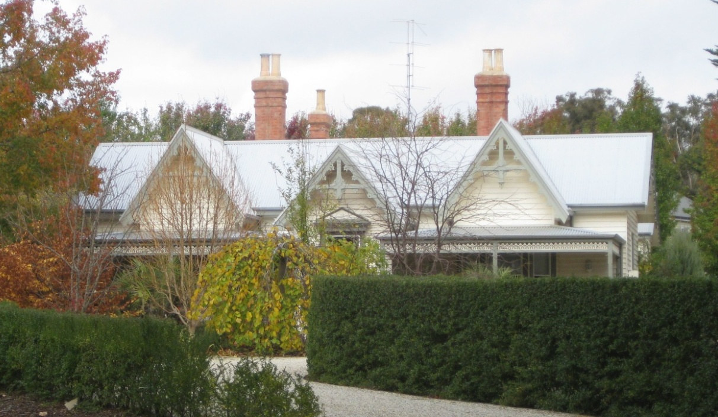

Figure 1. 18 Brooke Street, Woodend (GJM Heritage/Frontier Heritage, May 2018)

***What is significant?***

Blanchwood, 18 Brooke Street, Woodend, a house built c1878-81.

Elements that contribute to the significance of the place include (but are not limited to):

* The house’s original form, materials and detailing
* The house’s high level of integrity to its original design
* Gardens, including mature Monterey cypress plantings along the Brooke Street boundary.

*Description*

Blanchwood is set in expansive grounds and surrounded by mature Monterey cypress.

The coachhouse at the rear of the original property (now on a separate title at 7 Day Street, Woodend) has not been assessed.

***How is it significant?***

Blanchwood is of local historical, architectural and aesthetic significance to the Shire of Macedon Ranges.

***Why is it significant?***

Blanchwood is illustrative of the establishment of summer houses in accessible rural townships from the 1870s by wealthy Victorians. Used as a convent for many years, Blanchwood has strong associations with the Catholic Church and the early role it played in Catholic education in Woodend (Criterion A).

Blanchwood is a fine and intact example of a Victorian house unusually designed in a Rustic, or Carpenter, Gothic style more commonly applied to church design. It displays typical features of this style including prominent steep pitched gable ends, decorative bargeboards and bay windows (Criterion B).

Blanchwood is a well-considered and carefully detailed house set in expansive grounds. The timber house, with steep pitched roofs, prominent gables, tall chimneys, highly decorative bargeboards and bay windows and grounds presents a highly picturesque composition (Criterion E).

*Summary*

Blanchwood, Woodend is of note as a well-considered and finely detailed example of a summer house set in expansive grounds built in a rural township. Blanchwood is an unusual example of a late nineteenth century house, built in timber and designed in a Victorian Rustic Gothic, or Carpenter Gothic style; a style which was more commonly applied to churches than residential buildings. There appear to be no direct comparisons in the Shire.

**Image**



Figure 2. Boundary fence and mature Monterey cypress (GJM Heritage/Frontier Heritage, May 2018)

**Aerial**

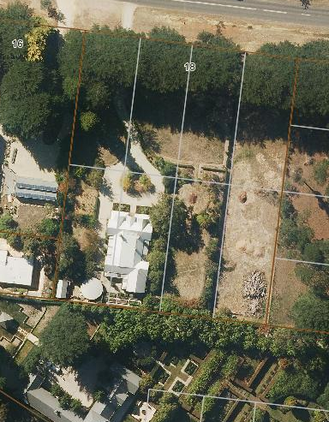

Figure 3. Aerial photo of 18 Brooke Street, Woodend (Source: Macedon Ranges Shire Council, aerial dated March 2018).

**Primary source:**

*Macedon Ranges Shire Heritage Study: Woodend, Lancefield, Macedon & Mount Macedon Stage 2 Final Report Volumes 1 and 2* (GJM Heritage and Frontier Heritage, April 2019)