**Ard Rudah Statement of Significance, May 2021**

|  |  |
| --- | --- |
| **Heritage place:** Ard Rudah 51 Devonshire Lane, Mount Macedon | **PS ref no.:** HO329 |

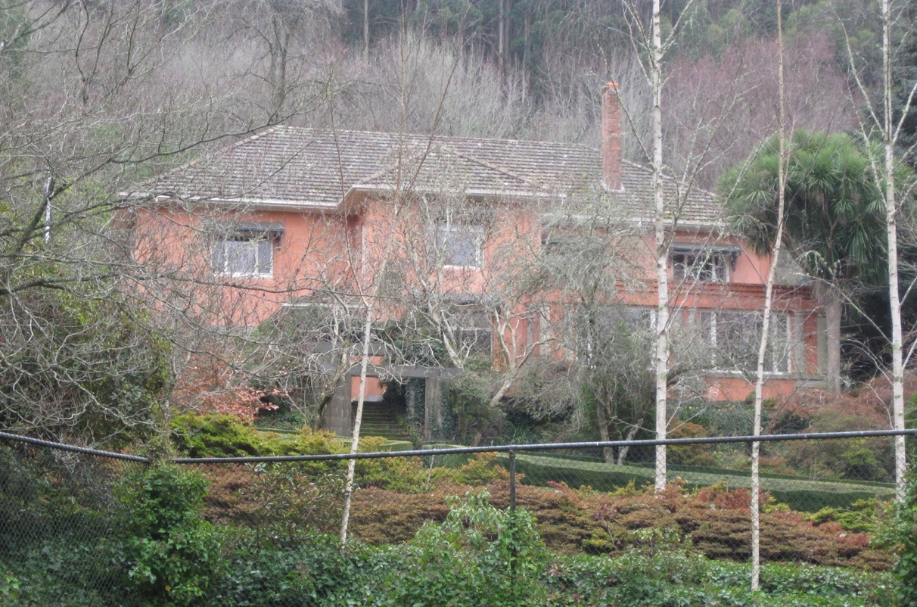

Figure 1. 51 Devonshire Lane, Mount Macedon (GJM Heritage/Frontier Heritage, June 2018)

***What is significant?***

Ard Rudah, 51 Devonshire Lane, Mount Macedon, a hill station established in the 1870s and including an Inter-war house.

Elements that contribute to the significance of the place include (but are not limited to):

* The external form, materials and detailing of the Inter-war house
* The house’s high level of integrity to its Inter-war design
* Outbuildings and fences that date to pre 1960s

*Description*

At the rear of the house, set into the hill and garden area is a small painted brick structure that may have been associated with the original nineteenth century house. The current use of the building is general storage, but it may have originally been a meat house or similar.

To the north east of the house is the large timber garage and carport structure with a low-pitched metal clad gable roof over. The structure is partially weatherboard clad with timber framed double hung sash windows and timber doors. Beyond the garage further to the east is the stables building.

* Gardens, including mature plantings, structures, stone walls and paving, water features

*Description*

The winding driveway rises through the landscaped grounds, past the tennis court and up to the house which is sited to the north west of the property.

A flat ground area had been created on the hillside on which the house sits facing south east, overlooking the extensive garden and tennis court.

The property includes a substantial landscaped garden area with water features, rockeries, paths, a tennis court and numerous substantial trees.

Recent alterations and additions are not significant.

***How is it significant?***

Ard Rudah is of local historical, architectural and aesthetic significance to the Shire of Macedon Ranges.

***Why is it significant?***

Ard Rudah has strong associations with the establishment of hill stations at Mount Macedon by prominent and wealthy Victorians from the 1870s. The place clearly illustrates the initial establishment, and the subsequent development, of the mountain as a summer retreat comprising large garden estates with substantial houses set in extensive grounds (Criterion A).

Ard Rudah is a representative example of a hill station established at the mountain location from the 1870s. It displays typical features of this place type, including extensive grounds, a large, prominent house, outbuildings and a variety of separate gardens, garden features and structures (Criterion D).

Ard Rudah is a highly developed picturesque hill station. Extensive grounds, containing a prominently-sited house, mature plantings, a walled garden, stone walling, paving and structures, water features and rockeries, present a picturesque composition (Criterion E).

Ard Rudah has close associations with well-known Melbourne architect Christopher Cowper, the owner and occupant of the house from the 1920s to the 1950s. Cowper was largely responsible for the design of the existing house and much of the extensive garden and he was closely associated with the development of the town of Mount Macedon. His local involvement resulted in electricity reaching the town, the sealing of the main access road and the construction of community halls (Criterion H).

*Summary*

Ard Rudah, Mount Macedon is of note as a fine and representative example of a Mount Macedon hill station. Ard Rudah retains its extensive grounds, Inter-war house, outbuildings and a number of developed garden areas within the property boundaries. Despite modifications to both the buildings and garden, the place has clear associations with the important hill station class of place.

**Image**



Figure 2. ‘Ard Rudah Guest House‘ from the tennis court, postcard probably dates to the 1950s (SLV, Image H32492/6343).

**Aerial**



Figure 3. Aerial photo of 51 Devonshire Lane, Mount Macedon (Source: Macedon Ranges Shire Council, aerial dated March 2018).

**Primary source:**

*Macedon Ranges Shire Heritage Study: Woodend, Lancefield, Macedon & Mount Macedon Stage 2 Final Report Volumes 1 and 2* (GJM Heritage and Frontier Heritage, April 2019)