**Ard Choille Cottage, Stables, Fernery & Garden Statement of Significance, May 2021**

|  |  |
| --- | --- |
| **Heritage place:** Ard Choille Cottage, Stables, Fernery & Gardens, 80 (part) Turner Ave, Mount Macedon | **PS ref no.:** HO336 |

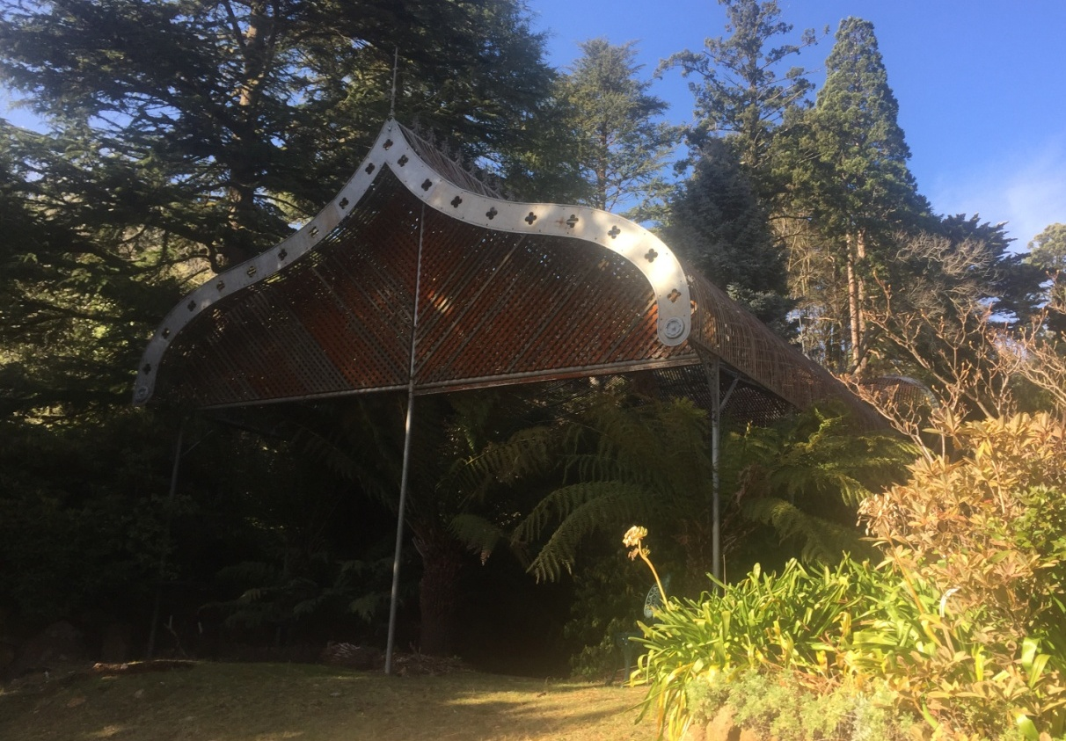

Figure 1. 80 (part) Turner Avenue, Mount Macedon (GJM Heritage/Frontier Heritage, July 2018)

***What is significant?***

Ard Choille, 80 (part) Turner Avenue, Mount Macedon, a late nineteenth century hill station, including a cottage, stable, large fernery and garden.

Elements that contribute to the significance of the place include (but are not limited to):

* Early outbuildings, including cottage and stables

*Description Summary*

Up the hill behind the house are the timber stables and timber cottage both dating from the late nineteenth century. The weatherboard-clad cottage has intersecting gable roofs of corrugated sheet metal and decorative timber barge boards.

On the east side of the cottage is the former timber stables building which has been converted to residential use. The former stables building is timber framed, gable roofed with a brick chimney on the east side.

Further up the hill, south of the cottage and former stables is the metal fernery. It is formed in two distinct sections, both rectangular in plan form with open sided framing of metal piping. The roof of each section has a very distinct ogee profile frame which is clad in evenly spaced metal lathe strips with an ornamental metal cresting along the ridges and metal finials at the ends.

* Gardens, including fernery, water features and mature plantings.

*Description Summary*

The gravel drive winds through a mature garden.

The extensive grounds retain many original features such as stone paths and edges, water features, water reticulation system of lochs (lakes) and plantings featuring many large conifers, deciduous trees, colourful shrubs and remnant gums. To the west of the house is a large ornamental lake (House Loch) in the shape of Australia which is lined with bluestone. The lake feeds a rivulet and fern gully from its overflow and it is fed by a spring. The water passes through a series of ponds from the upper sections of the property. The spring is located within a large lake in a cleared opening with mature specimen trees, both indigenous and exotic and bordered by bushland. The spring also feeds the extensive water reticulation system which serves the whole garden and small fountains. The descending series of pools from the upper pond are connected by a fern gully and a line of demarcation on either side of the stream is provided by rough stone edging. A narrow path winds between the ponds connecting the upper level of the property with the house site.

The following trees are understood to remain from the original plantings –

* Rimu (*Dacrydium cupressinum*) near to the entrance gate,
* Holly (*Ilex Kingiana*), south west corner of the croquet lawn,
* Japanese Cedar (*Cryptomeria Japonica),* south west corner of the croquet lawn*,*
* *Cedrus Deodara,* north west corner of croquet lawn*,*
* Tulip Tree (*Liriodendron),* south side of the house lake,
* Tree Rhododenron (*Rhododenron arboretum*), adjacent to the house.

The late twentieth century house, reconstructed gates, modern outbuildings, and recent alterations and additions made to the cottage and stables, are not significant.

***How is it significant?***

Ard Choille is of local historical, architectural and aesthetic significance to the Shire of Macedon Ranges.

***Why is it significant?***

Ard Choille has strong associations with the establishment of hill stations at Mount Macedon by prominent and wealthy Victorians from the 1870s. The place clearly illustrates the initial establishment, and the subsequent development, of the mountain as a summer retreat comprising large garden estates with substantial houses set in extensive grounds (Criterion A).

The fernery at Ard Choille is a fine and rare surviving example of a large fernery located in a privately-owned garden, designed by nurseryman William Sangster. It displays typical features of a nineteenth century fernery structure including a distinct ogee profile frame, metal lathe cladding and decorative elements (Criterion B).

Ard Choille is a representative example of a hill station established at the mountain location from the 1870s. It displays typical features of this place type, including extensive grounds, outbuildings, fernery, water features and a collection of mature trees and other plantings (Criterion D).

Ard Choille is a highly developed picturesque hill station. Extensive grounds, containing a finely detailed and elegantly curved fernery structure, water features and mature plantings present a highly picturesque composition, as thought to be depicted by Frederick McCubbin in ‘The Pioneer’ (1904) (Criterion E).

*Summary*

Ard Choille, Mount Macedon is of note as a fine and representative example of a Mount Macedon hill station. Ard Choille retains its extensive grounds, outbuildings and garden which includes a large late nineteenth century fernery, mature trees and other plantings. Despite modifications to these, the place has clear associations with the important hill station class of place.

**Image**



Figure 2. South side of former stables (GJM Heritage/Frontier Heritage, July 2018

**Aerial**



Figure 3. Aerial photo of 80 Turner Avenue, Mount Macedon (Source: Macedon Ranges Shire Council, aerial dated March 2018).

**Primary source:**

*Macedon Ranges Shire Heritage Study: Woodend, Lancefield, Macedon & Mount Macedon Stage 2 Final Report Volumes 1 and 2* (GJM Heritage and Frontier Heritage, April 2019)