**Annie Vale Farm Complex Statement of Significance, May 2021**

|  |  |
| --- | --- |
| **Heritage place:** Annie Vale Farm Complex, 158 (part) Mahers Road, Lancefield | **PS ref no.:** HO321 |

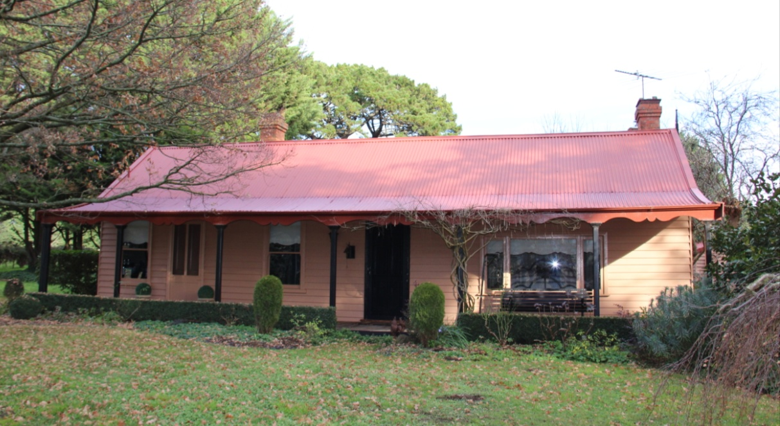

Figure 1. 158 (part) Mahers Road, Lancefield (GJM Heritage/Frontier Heritage, July 2018)

***What is significant?***

Annie Vale Farm Complex, 158 (part) Mahers Road, Lancefield, a farming property established in the mid-late nineteenth century.

Elements that contribute to the significance of the place include (but are not limited to):

* The farmhouse’s original form, materials and detailing
* The farmhouse’s high level of integrity to its original design
* Early outbuildings

*Description Summary*

To the north of the main house is one of the outbuildings which may be contemporary with the house construction. This structure is currently used as a garage and general storage. The structure appears to have been built in stages with walls that are a combination of painted brickwork, weatherboard cladding and corrugated sheet metal cladding. The roof is gable form with a skillion section to the side. There is a brick chimney on the northern side.

Behind the house, on the west side there is another residential cottage, a timber outhouse and a small timber storage shed. The cottage is unusual in architectural detailing. The walls are a rough rendered and painted finish and the gable roof is clad with corrugated sheet metal. A simple draped verandah with timber posts extends along the east wall.

South west of the main house group of buildings is the coach house. The steeply pitched central gable section of corrugated sheet metal has broad skillion sections either side. Timber finials adorn the gable ends and the east wall is of painted weatherboards and other walls are painted corrugated sheet metal clad.

There are several other outbuildings along the south west boundary of the property. These outbuildings are timber framed, weatherboard clad with corrugated sheet metal roofs. They appear to consist of predominantly mid-late nineteenth century building fabric and are therefore of a similar period to the residential buildings on the property.

* Entrance fence, and mature trees and plantings.

*Description Summary*

The building complex is set in an ornamental landscape of tree rows, hedges and plantings in the north east corner of the site. There are post and wire fences.

The main house is reached via a tree lined driveway off Mahers Road.

The landscaping around the buildings is well maintained. There are exotic trees, generally mature, including willows and Lombardy poplars, cypress and pines. There is extensive well-maintained hedging throughout the property.

***How is it significant?***

Annie Vale Farm Complex is of local historical and architectural significance to the Shire of Macedon Ranges.

***Why is it significant?***

Annie Vale Farm Complex demonstrates the early establishment and subsequent development of farming properties in the rich agricultural district of Lancefield (Criterion A).

Annie Vale Farm Complex is a fine, intact and representative example of a nineteenth century farming property. It displays typical features of a farm complex in Lancefield and across Victoria more broadly, including a farmhouse, outbuildings and mature plantings (Criterion D).

*Summary*

The Annie Vale Farm Complex, Lancefield is of note as a representative and intact example of a farming property in the Shire of Macedon Ranges. The district gained a reputation as a rich agricultural area and properties such as this clearly illustrate this development. It displays a range of typical characteristics of a farm complex from the period within the municipality including a single-storey dwelling, a range of associated outbuildings, mature vegetation and a sizable allotment of farming land.**Image**



Figure 2. Entrance fence off Mahers Road (GJM Heritage /Frontier Heritage, July 2018)

**Aerial**



Figure 3. Aerial photo of 158 (part) Mahers Road, Lancefield (Source: Nearmap, aerial dated Jan 2018).

**Primary source:**

Macedon Ranges Shire Heritage Study: Woodend, Lancefield, Macedon & Mount Macedon Stage 2 Final Report Volumes 1 and 2 (GJM Heritage and Frontier Heritage, April 2019)