2021–25

Version
Document history | Version | Date | Author
Draft DAMP | 1 | 29 October 2021 | Allie Jalbert
Draft DAMP | 2 | 24 November 2021 | Allie Jalbert
Final Draft DAMP | 3 | 14 February 2022 | Allie Jalbert
Council Approved DAMP | 3 | 23 February 2022 | Allie Jalbert
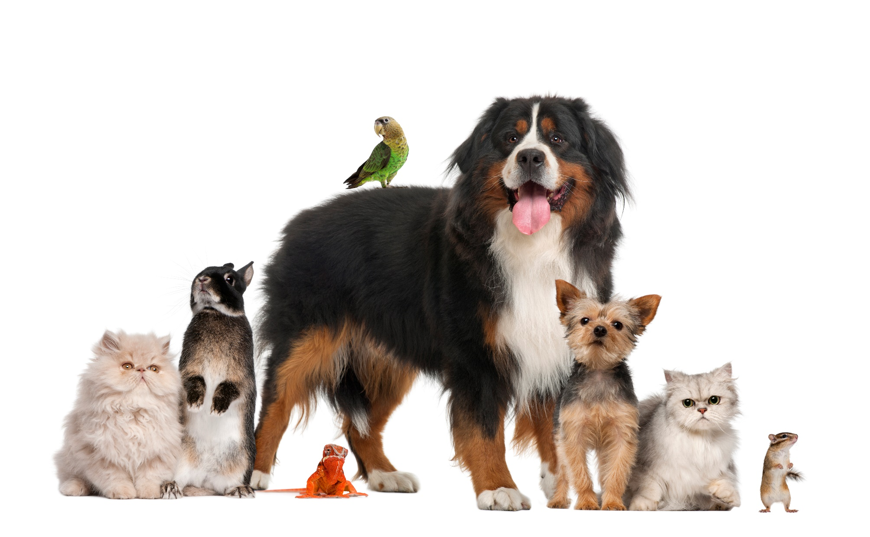

Table of Contents

1. Introduction 5

What is a Domestic Animal Management Plan? 5

Why have a plan? 5

How does the plan fit with the Council Plan? 6

Other relevant legislation that guides animal management 6

How does the plan fit with State Policy objectives? 6

2. Our Framework 7

Vision for the next four years 7

3. Our Shire 8

Shire population growth and demographics 9

4. How we developed this plan 10

Review of the previous plan 10

Community Consultation 11

What you told us 12

The current status 13

Animal Management Staffing and Structure 15

5. Training of Authorised Officers 16

Current Situation 16

Current and Ongoing Training Activities 16

Our Plans 17

6. Registration and Identification 18

Current Situation 18

Data for the number of dog and cat registrations for the last four years 19

Our Orders, Local Laws, Council Policies and Procedures 19

Current Education and Promotion Activities 20

Current Compliance Activities 20

Summary 20

Our Plans 21

7. Responsible Pet Ownership and Reducing Nuisance 22

Current situation 22

Our Orders, Local Laws, Council Policies and Procedures 23

Current Education and Promotion Activities 24

Current Compliance Activities 24

Summary 26

Our Plans 26

8. Dog Attacks 29

Current Situation 29

Our Orders, Local Laws, Council Policies and Procedures 30

Current Education and Promotion Activities 30

Current compliance activities 30

Summary 31

Our Plans 31

9. Dangerous, Menacing and Restricted Breed Dogs 32

Current situation 32

Our Orders, Local Laws, Council Policies and Procedures 33

Current Education and Promotion Activities 33

Current compliance activities 33

Summary 34

Our Plans 34

10. Overpopulation and high euthanasia 35

Current Situation 35

Our Orders, Local Laws, Council Policies and Procedures 37

Current Education and Promotion Activities 37

Current compliance activities 37

Summary 38

Our Plans 38

11. Domestic Animal Businesses 39

Current situation 39

Our Orders, Local Laws, Council Policies and Procedures 39

Current Education and Promotion Activities 40

Current compliance activities 40

Summary 41

Our Plans 41

12. Other Matters – Supporting the Community in Emergencies 42

Current Situation 42

Our Orders, Local Laws, Council Policies and Procedures 42

Current Education and Promotion Activities 43

Summary 43

Our Plans 43

13. Other Matters – Promoting Council’s Animal Services 44

Our Orders, Local Laws, Council Policies and Procedures 44

Current Education and Promotion Activities 44

Summary 45

Our Plans 45

14. Annual Review of Plan and Annual Reporting 46

Our Plans 46

Appendix 1 – General Purpose and Amenity Local Law No. 10 of 2013 47

Division 1 – General Requirements 47

Division 3 – Animal Control 47

- Introduction

What is a Domestic Animal Management Plan?

All Victorian Councils are required by the Domestic Animals Act 1994 (the Act) to prepare and implement a four-year Domestic Animal Management Plan (DAMP) to guide decision making regarding animal management for dogs and cats.
This four-year DAMP builds on the DAMP 2017-2021. It provides a framework for the planning, development, and evaluation of animal management services and programs delivered by Macedon Ranges Shire Council to comply with the requirements of the Act.
It is a legislative requirement that the DAMP addresses the following:
- Set out a method for evaluating whether animal control services provided by the council are adequate to give effect to the requirements of the Act and regulations
- Outline programs for the training of authorised officers
- Outline programs, services and strategies to:
- Promote and encourage responsible pet ownership of dogs and cats;
- Ensure that people comply with the Act, regulations and other relevant legislation;
- Minimise the risk of attacks by dogs on people and animals;
- Address over-population and high euthanasia rates for dogs and cats;
- Encourage the registration and identification of dogs and cats;
- Minimise the potential for dogs and cats to create a nuisance; and
- Effectively identify all dangerous, menacing and restricted breed dogs and ensure these dogs are kept in compliance with the Act and regulations.
- Provide for review of existing orders and Local Laws made under the Act
- Provide for the review of any other matters related to the management of dogs and cats.
- Provide for periodic evaluation of the plan

Why have a plan?

Council recognises that pets play an important role in many peoples day – to- day lives in our community, providing companionship and benefiting overall health and wellbeing. Council strives to support pet owners and promote the health and social benefits of responsible pet ownership. This is done in conjunction with ensuring that our environment and lifestyle are protected from any potential negative impacts of domestic animals.
The Macedon Ranges Domestic Animal Management Plan aims to ensure that people and pets can live harmoniously in our community. The plan recognises and carefully balances the needs of pets, pet owners and those who don’t own pets. The plan is designed to respond strategically to community needs as a whole, and help protect the natural environment that makes the Macedon Ranges such a special place to live and work.

How does the plan fit with the Council Plan?

The Council Plan 2021–2031 was recently adopted, which strives to achieve the community’s vision of Macedon Ranges Shire 2021–2031, and is aligned with Council’s four strategic priorities, developed through the Community Vision Assembly’s deliberative engagement process:
Connecting Communities
Healthy Environment, healthy people
Business and tourism
Delivering strong and reliable government.
The Domestic Animal Management Plan 2021 - 2025 aligns with the Council Plan 2021 – 2031 by setting out objectives that support Council’s strategic priorities.

Other relevant legislation that guides animal management

- Planning and Environment Act 1987
- Prevention of Cruelty to Animals Act 1986, associated Regulations, and Codes of Practice
- Domestic Animals Act 1994, associated Regulations, and Codes of Practice
- Macedon Ranges Shire Council General Purposes and Amenity Local Law No.10 of 2013 (relevant clauses are listed in Appendix 1)

How does the plan fit with State Policy objectives?

In developing this plan, careful consideration was given to the Victorian State Government’s strategic priorities and policy objectives, including the Victorian Animal Welfare Action Plan and the anticipated introduction of a new animal welfare Act.
- Our Framework

Vision for the next four years

In partnership with the Macedon Ranges community, provide for the best possible interactions between pets, people, and the environment.

The following principles will guide our work:

We recognise the physical, mental and social benefits that pets bring.
Our activities recognise the importance of pets in our community and their positive role in our overall health and wellbeing, both physically and mentally. We support and encourage residents to enjoy the companionship of their pets.

We balance the needs of pets, pet owners and those who don’t own pets
We consider the different needs of those who own pets and those who don’t, and strike a fair balance in activities and actions relating to animal management.

We protect the environment from any negative impacts from domestic pets
Our activities aim to protect our native fauna and flora by reducing the impacts of pets on the natural environment.

We promote a high standard of animal welfare
We will educate and raise awareness in our community about pet owners’ responsibility to ensure a high standard of animal welfare for all animals in their care.

We work in partnership with the community, agencies and organisations to enhance and promote responsible pet ownership.
We partner with a range of agencies and organisations that work with pet owners or deliver services in our community to promote responsible pet ownership.
- Our Shire
Macedon Ranges Shire is approximately 60km north-west of Melbourne and covers an area of 1,747 square kilometres. Macedon Ranges Shire is on the land of three traditional owners, the Dja Dja Wurrung, Taungurung and Wurundjeri peoples.
The Macedon Ranges population is spread across nine towns and a number of smaller settlements. The largest towns are Gisborne, Kyneton, Lancefield, Romsey and Woodend. About 35% of people in Macedon Ranges live outside a town boundary in a rural setting. Over the next 10 years, the Macedon Ranges population is expected to increase by approximately 18.3% to reach 60,362 by 2031. Most of this population growth is projected to occur in the south and south-east of the shire.
The Macedon Ranges Shire is renowned for its rural character, semi-rural lifestyle, landscapes and forests, and unique natural features such as Hanging Rock and Mount Macedon.
As the shire grows and urban areas spread into rural areas, there will be increasing pressure to protect the natural environment and preserve rural lifestyles. Community expectation for services and facilities is changing as the population grows. Residents moving into rural areas are not always aware of the impacts that pets can have on wildlife and livestock, and those living closer to townships want to see more facilities and services that support residents with pets. Our animal services, programs, and infrastructure must continue to evolve and improve to meet these challenges.
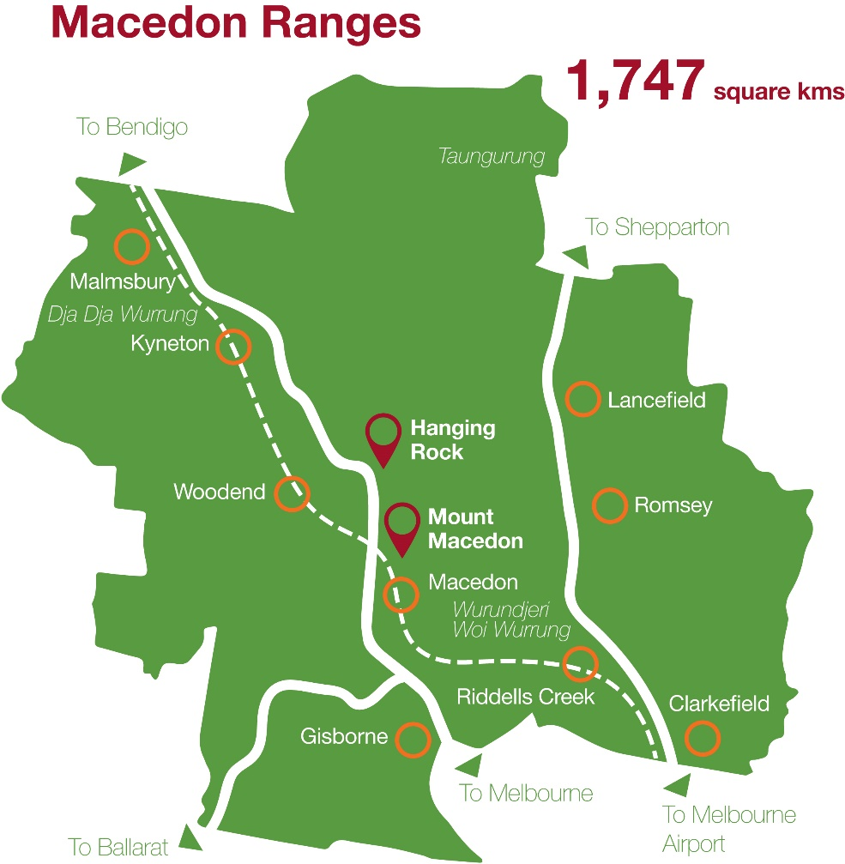

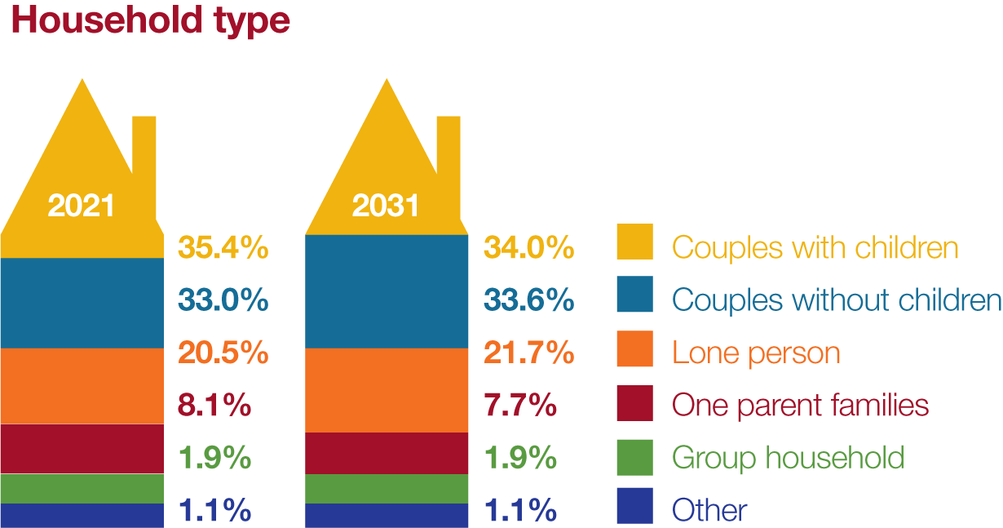
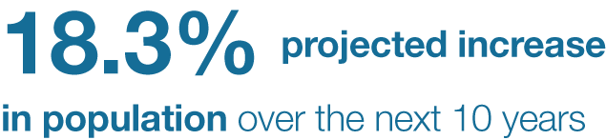
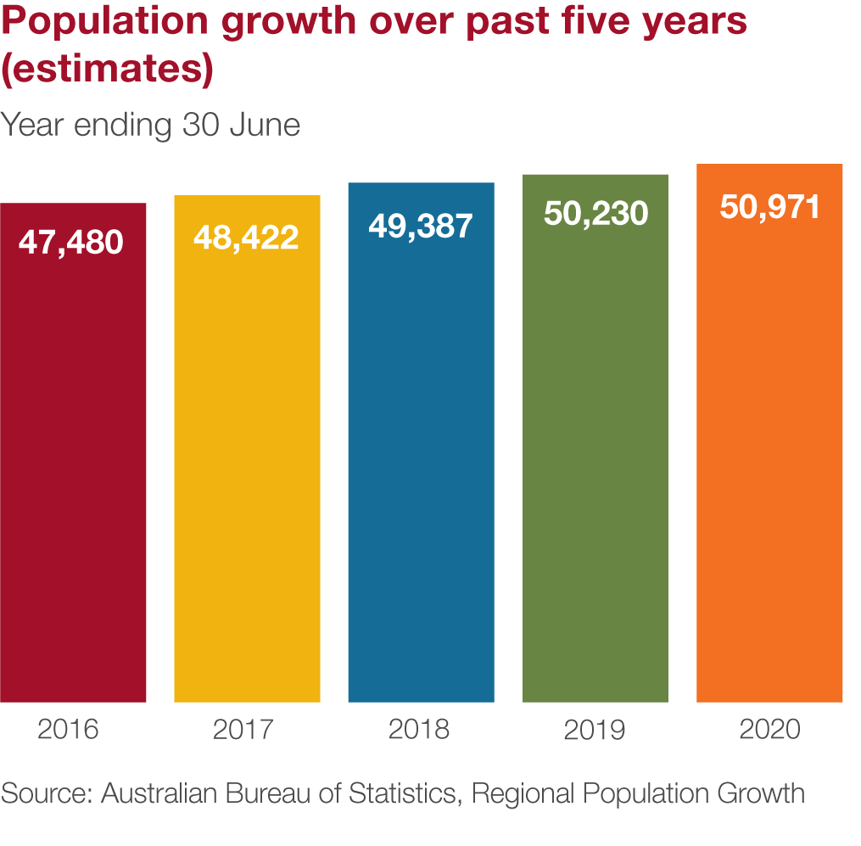
Shire population growth and demographics

How we developed this plan

Review of the previous plan

In developing this plan, we started by looking at what had been achieved in the Domestic Animal Management Plan 2017 - 2021 and what initiatives have been successful. Of the activities listed in the previous plan, most were delivered. However, the delivery of some activities was impacted by the COVID-19 pandemic, and were reconsidered for inclusion in the next DAMP.
Key initiatives delivered as part of the 2017 – 2021 DAMP included:
- A review of how dogs and cats are managed in public spaces resulted in the introduction of the Council Dog and Cat Order 2019. The order requires dogs to be on leash except in designated off leash areas, introduced over 50 off leash areas across the Shire, introduced five prohibited areas for pets to protect sensitive environmental areas, established effective control requirements for dogs, and brought in a sunset to sunrise cat curfew.
- Introduced free 1st year registration for desexed cats to increase cat identification and improve the number of lost cats reunited with owners.
- Improved information available for cat containment options and transitioning outdoor cats to being contained.
- Implemented online pet registration making it easier to register new pets or register when moving into the shire.
- Introduced eNotices for pet registration renewals to be delivered via email, making renewals faster and easier, while being better for the environment.
- Reviewed our cat shelter services, partnered with a new shelter provider, and built a dedicated Council operated temporary holding facility. Council can hold cats and dogs for up to 24 hours while rangers try to identify and contact owners.
- Implemented emergency pet welfare boarding for vulnerable members of the community who may be experiencing family violence or other personal crisis where support is needed.

While not an action in the previous plan, improving data capture and the ability to report on outcomes for impounded animals was another key priority delivered.

Community Consultation

Central to the development of this plan is input from the community. A consultation plan was developed to guide how we would consult with the community on this plan. There were two stages of community consultation conducted. Feedback from both consultations have helped guide development of activities in this plan.

What you told us

Community consultation for the development of the Domestic Animal Management Plan 2021-2025 was undertaken in two stages.
Stage one of the community consultation was conducted from 21 September to 18 October 2021. During stage one, Council sought input from the community, industry groups, special interest groups, and key stakeholders to help inform actions and priorities to be included in the draft plan.
Stage two of the community consultation presented the draft Domestic Animal Management Plan 2021-2025 for the community to provide further feedback to help shape the final plan presented to Council for adoption.
Through both stages of community consultation, a range of themes summarised below emerged as priorities from the community feedback:
- A want for improved dog friendly infrastructure in open space – securely fenced off leash area options, more poo bag dispensers and bins for off leash areas and heavily used dog walking paths, better signage, and dog drink stations.
- Strong support for dedicated purpose built and well-designed off leash dog parks.
- The most prevalent concern with dogs is poo not picked up in public places, with many comments about improving education, signs, and availability of bag dispensers to address this.
- Some owners are not adhering to leash requirements or do not have effective control of dogs with calls for increased education and enforcement.
- Select comments about the suitability of specified existing designated off leash areas with requests to review some areas, and requests for additional off leash areas to keep up with growth.
- Moderate levels of compliance with the existing sunset to sunrise cat curfew, with many calling for greater education / enforcement, some calling for moving to 24 hour containment requirements and some calling for there not to be any cat curfew.
- Ongoing concerns about the impact of cats on wildlife and the environment, and recognition that cats are sometimes relied upon to help control rodents and vermin (eg. In farm environments).
- Strong support for Council offering subsidised low cost cat desexing to reduce the number of unwanted cats and better protect the environment.
- Support for Council incentives to improve registration and encourage responsible pet ownership.
- Concerns about a perceived lack of localised services for lost pets – vets not able to return pets directly, no local pound/shelter (pound provider being in North Melbourne).
These themes helped shape the plan’s objectives and activities in the relevant area of focus, with some themes crossing over into more than one focus area.

The current status

1 July 2020 – 30 June 2021
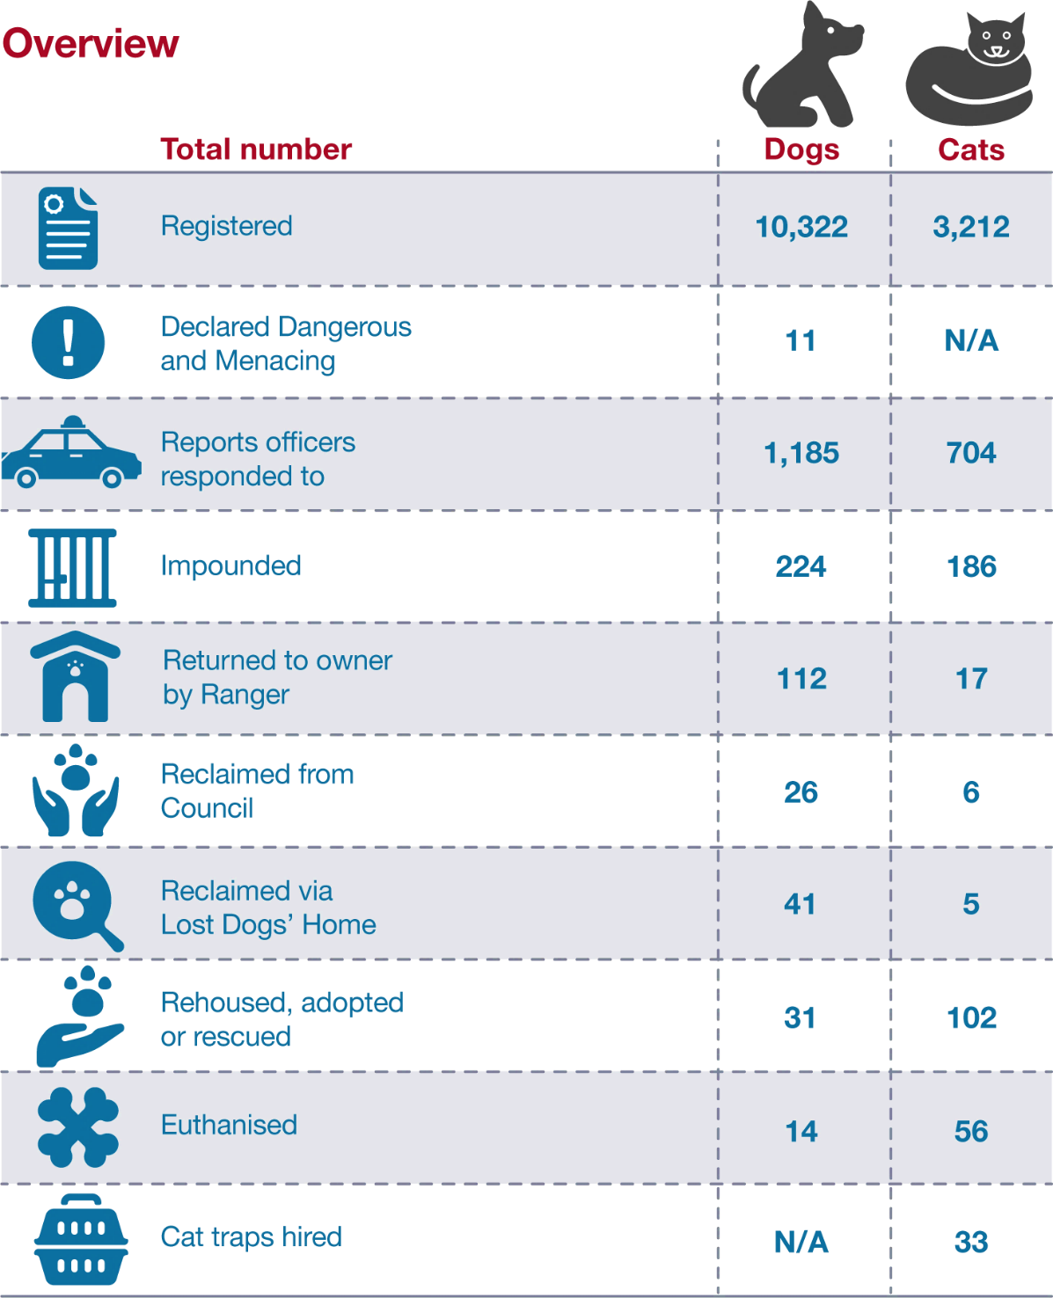

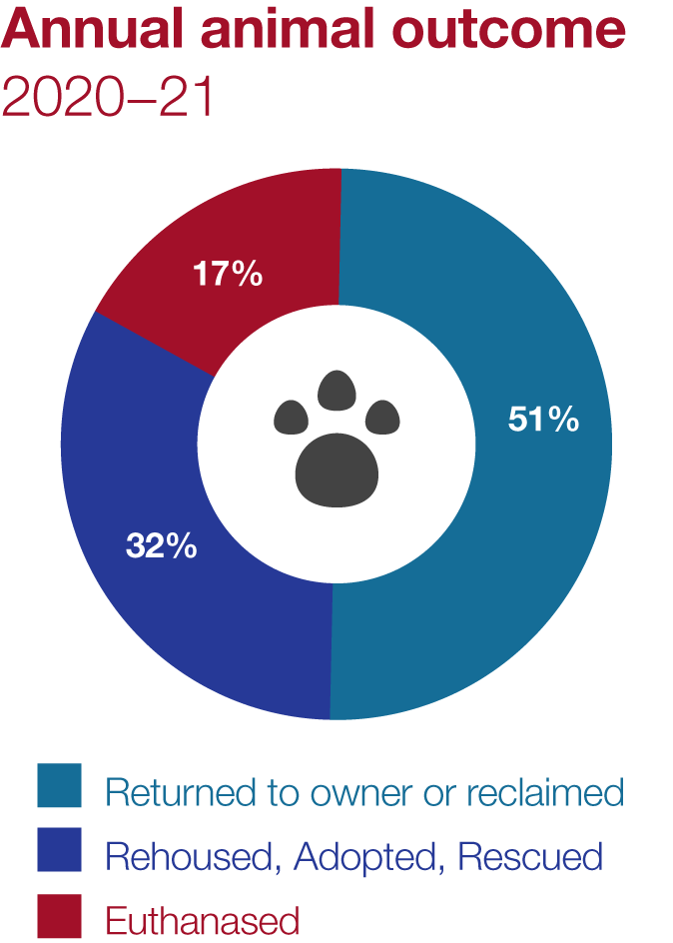
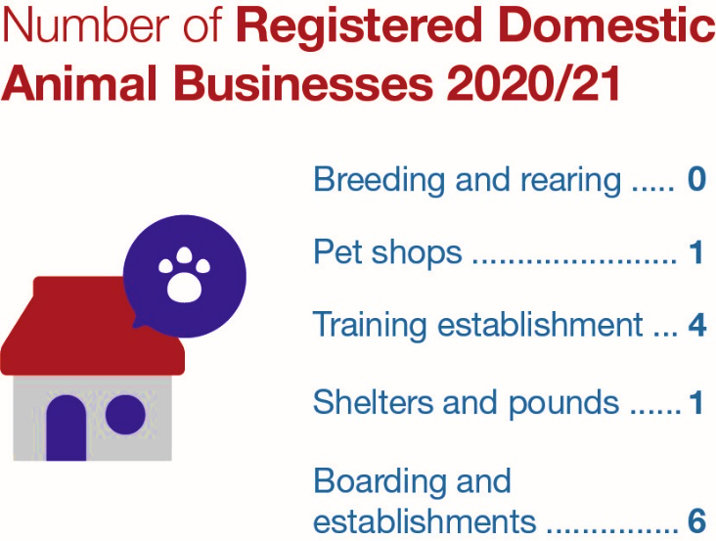

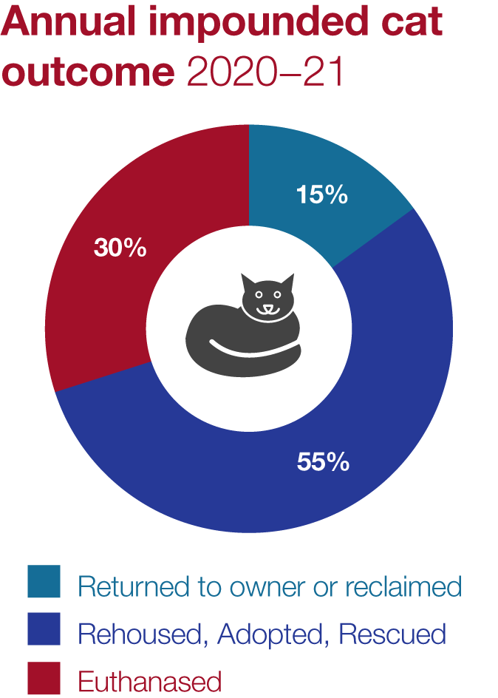
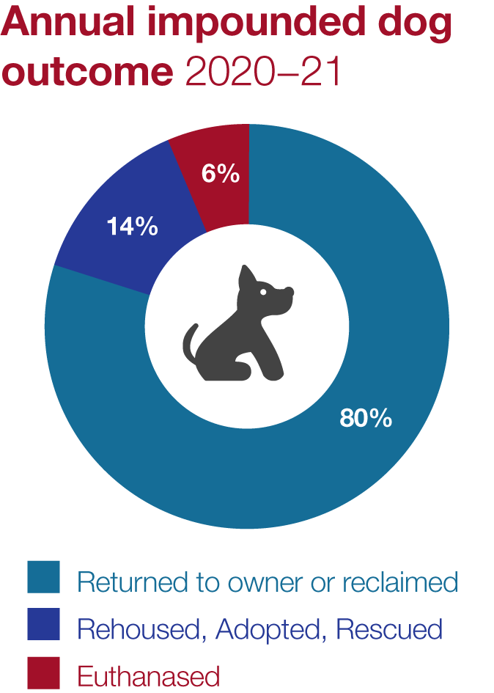

Animal Management Staffing and Structure
Animal management is the responsibility of the Local Laws Unit at Council as part of the Safer Communities Department. Animal management makes up about 70% of the work undertaken by the unit. There are four fulltime Local Laws Officers (Ranger), a Team Leader and a Coordinator who undertake operational and enforcement activities. In addition, a Senior Local Laws Support Officer and two EFT Business Support Officers provide administrative and customer support. Casual and agency support staff are also utilised as required to meet operational demands.
The Local Laws Unit provides an emergency after-hours service throughout the year. As part of the after-hours service, Officers are on call to attend emergencies such as threatening dogs, dog attacks and injured animals. Additionally, Officers provide phone support for lost and found pets to reunite pets with owners quickly, and attend to collect found animals between 8.30am to 5.30pm when Council cannot contact owners.
- Training of Authorised Officers

Legislative Context – Domestic Animals Act 1994, Section 68A(2)(b) - Outline programs for the training of authorised officers to ensure that they can properly administer and enforce the requirements of the Domestic Animals Act 1994 in the Council’s municipal district.

Current Situation

Due to the size of the shire, officers are allocated service areas that incorporate both rural and urban areas. Officers are required to have a sound understanding and knowledge of a range of acts and laws, including Council’s General Purposes and Amenity Local Law No.10, and apply this knowledge to various situations. Apart from administering and enforcing these laws, officers need to communicate, educate and support community members effectively, diffuse difficult situations, safely handle animals, assess animal welfare and perform many other duties.
A wide range of training is offered and provided to all officers. Training ensures they are equipped to respond to the demands of their roles and can work effectively in conjunction with other agencies.

Current and Ongoing Training Activities
Macedon Ranges Shire Council’s current officer training and future development activities are developed in consultation with staff and designed to ensure all officers have the necessary training and qualifications to undertake their role.
Training needs are individually assessed for each officer and included in an annual staff development plan. Regular training is provided in a variety of formats. It provides industry-based training such as certificate courses, webinars and workshops, Occupational Health and Safety training, self-defence training, First Aid and CPR training, and annual corporate e-learning such as conflict of interest training, privacy training, and bullying and harassment training.
Council recognises the links between animal cruelty and human violence, and is committed to providing training for officers in recognising abuse.

Our Plans
Objective: Ensure Local Laws officers have the skills necessary to support the community and effectively perform their regulatory role.

Activity | Commence | Evaluation
Provide updated training to Local Laws officers in application of the Domestic Animals Act 1994 and the Prevention of Cruelty to Animals Act 1986. | ongoing | Local Laws staff will undertake training for continuous improvement in line with legislative changes.
Ensure all Local Laws Officers (permanent staff) have current membership with the Australian Institute of Animal Management. | 2021 and ongoing | Local Laws Officers will have access to industry resources and webinars to expand knowledge in best practice animal management and welfare.
Ensure all Local Laws staff attend Mental Health First Aid training or undertake a refresher course. | 2022 and ongoing | New staff will undergo training within 12 months of employment, and all staff will have refresher training every two years.
Local Laws staff will complete a minimum of one workshop, training session or webinar annually relevant to animal management or welfare. | ongoing | Annual development plan will include a workshop, training session or webinar with outcomes recorded.
Ensure all Local Laws staff complete available training to create awareness about signs of abuse situations towards people and animals (E.g. family violence, child abuse, elder abuse). | Ongoing | New staff undergo training within 12 months of employment.

Registration and Identification
Legislative Context – Domestic Animals Act 1994, Section 68A(2)(c)(v) - Outline programs, services and strategies to encourage the registration and identification of dogs and cats. Other Sections addressed are 68A(2)(a),(c)(ii),(d), and (f).

Current Situation

Council’s priority is to ensure all lost dogs and cats can be returned quickly to their owner. Registration and microchipping is essential in enabling this to occur. The quick return of a pet reduces stress on the owner and pet, while also helping prevent a potential nuisance or injury occurring. Generally, there is a high compliance rate of pet owners registering their dogs in the shire. However, many lost dogs that are impounded each year do not have current Council registration.
The number of cats registered in the shire is slowly increasing, but remains much lower than the number of dogs registered. The much lower rate of registrations results in very low identification and reunification rates for impounded cats. Despite most cats entering our pound being friendly, most are not reclaimed by owners and need to be rehomed. Cat identification and registration remains a key priority to improve reunification rates.
Council has a 24-hour holding facility within the municipality for any dogs and cats that cannot be re-united with their owner immediately. Officers aim to return as many dogs and cats as possible in the field without these animals entering a pound. Where a direct return is not possible, animals are generally held for 24 hours (except on weekends, public holidays, and high fire risk days) while Officers try to locate an owner to reclaim directly from Council.
Council partners with the Lost Dogs Home to provide shelter care and rehoming services for pets that Council have not successfully been reunited with owners locally.

Data for the number of dog and cat registrations for the last four years

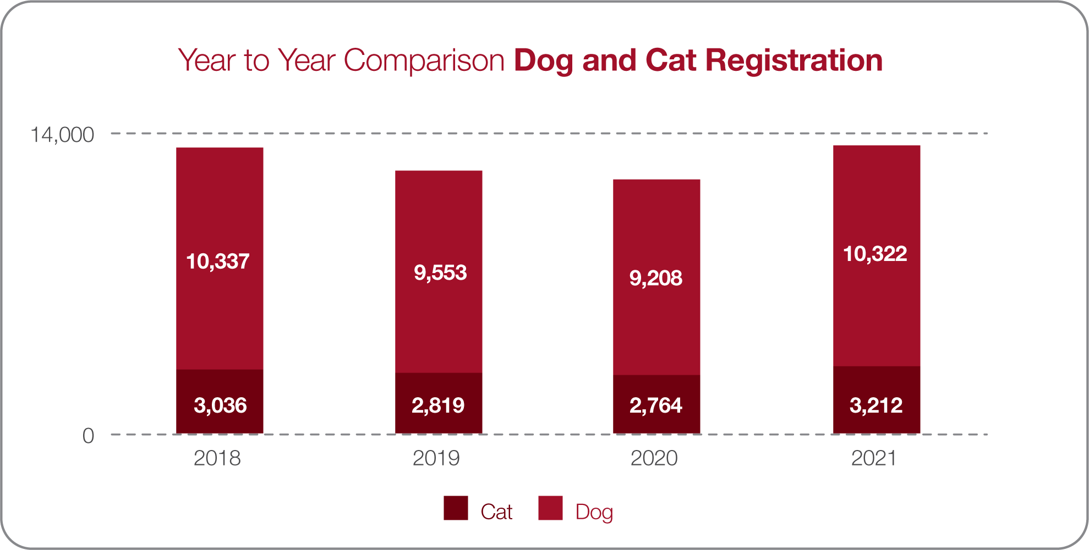

Our Orders, Local Laws, Council Policies and Procedures
Local Law:
General Purposes and Amenity Local Law No. 10 of 2013 – Division 3 Animal Control – Clause 42 regulates the number of dogs and cats that can be kept at a property without a permit depending on the land size.
Council Policies and Procedures
- Annual registration renewal and reminder notices, including the setting of fees.
- Legislative requirement for registration of dogs and cats at the age of three months.
- A mandatory fee structure is set out in the Domestic Animals Act 1994 as a legislative requirement, and Council sets the fee amount through its annual budget process.

Current Education and Promotion Activities

- Promotion of registration requirements through various communication methods, including Shire Life newsletter, local papers, community newsletters, council’s website and social media channels.
- Mailing / emailing out animal registration renewal and reminder notices annually to currently registered animals, follow up phone calls, and property visits.
- Reduced registration incentive for owners who purchase dogs and cats from registered animal shelters.
- First year free desexed cat registration incentive.
- Information in new resident’s kits.
- New pet registrations and registration renewals available online.

Current Compliance Activities

- Requiring unregistered impounded animals to be microchipped and registered prior to release.
- Following up with owners who have adopted or purchased new pets.
- Investigating complaints.
- Issuing notices for animals found unregistered.
- Issuing infringements for animals found unregistered
- Prosecuting owners of unregistered animals where infringements remain unpaid and/or animals remain unregistered.
- After hours animal emergency service.

Summary
Macedon Ranges Shire Council’s priority is to return lost pets to their owners as quickly as possible. Council aims to increase the number of animals registered across the shire, emphasising increasing the number of cats registered. Feedback received during the consultation indicates that some pet owners do not see value in registering their pets. Council will continue working with key partners to promote the benefits of pet registration and introduce further incentives to encourage registration.

Our Plans
Objective: Develop strategies in partnership with other agencies and organisations to increase Council registration and identification of dogs and cats.

Activity | Commence | Evaluation
Continue first year free registration initiative for desexed cats. | ongoing | Encourage cat desexing and registration by waving first year registration fees for desexed cats.
Introduce “1st free ride home” program. | 2022 and ongoing | Develop and implement a fee waiver incentive program for impounded pets with current Council registration (conditions apply).
Partner with local veterinarians and other pet care providers to promote the benefits of pet registration. | 2023 | Develop information materials about Council’s lost/found pet services and pet registration incentives for use by local veterinarians, dog trainers, and other pet care professionals servicing the community.
Pet registration enforcement checks via phone and home visits. | 2022–25 | Annual dedicated pet registration compliance checks targeting non-renewals and randomised door knocks for unregistered pets – aimed at increasing compliance with pet registration requirements.
Outreach activities to promote pet registration and responsible pet ownership | 2022–25 | Develop and implement a face-to-face outreach program for Officers to promote responsible pet ownership and benefits of pet registration.  (E.g. at markets, dog training locations, events)

Responsible Pet Ownership and Reducing Nuisance
Legislative Context – Domestic Animals Act 1994, Section 68A(2)(c)(i) - Outline programs, services and strategies to promote and encourage the responsible ownership of dogs and cats. - also addresses 68A(2)(a),(c)(ii),(c)(vi),(d),(f)

Current situation
The purpose of the Domestic Animals Act 1994 is to promote animal welfare, the responsible ownership of dogs and cats, and the protection of the environment. The Act contains regulatory provisions to address dog and cat nuisances relating to noise, trespassing and wandering animals. The Macedon Ranges Shire’s Local Law also has provisions that control animal nuisances such as limiting the number of cats and dogs that can be kept on any one property. The Local Law also defines, how any additional animals must be housed and the requirement for dog walkers to pick up their dog’s waste when in public places.
Reports about nuisance issues from dogs and cats have decreased over the past four years. The sharpest decrease was over the past two years, which may be attributable to the COVID-19 pandemic and associated restrictions on movement. Simply, more pet owners were home with their pets, enabling better supervision and management of problem behaviours. However, through the community consultation for this plan, concerns about dog poo in public places and dogs not under effective control remain issues for the community. In addition there are still significant concerns about the impact of cats on wildlife, and mixed views about the cat curfew with some wanting it extended to 24 hours and others not wanting a curfew at all.
Dog on leash and effective control requirements came into operation from 1 January 2020, and the sunset to sunrise cat curfew from 1 July 2020 as part of the Council Dog and Cat Order 2019. While respondents to the DAMP consultation had a high level of awareness of the new requirements, the levels of awareness in the broader community who did not engage with the consultation remains unknown. Feedback indicates there is still non-compliance being observed by dog and cat owners, indicating the need for increased education and enforcement.
Due to shifting priorities responding to the COVID-19 pandemic, Council did not progress the second stage of implementation involving the installation of additional signs and a community education program. As we move into COVID normal, activities to support the implementation of the Order are planned. We also plan to review designated off leash and prohibited areas to determine suitability and opportunities for alterations.
The community has consistently called on Council to provide a ‘pet friendly shire’ with improved facilities for dogs as part of open spaces. This plan identifies the need for dedicated off leash dog parks and additional shared off leash areas to be considered as part of strategic open space planning. With an emphasis on recognising the physical, mental and social benefits that pets bring, it is important to find the right balance in resolving nuisance issues. Education remains a high priority to encourage responsible pet ownership and help community members solve nuisance issues early without the need for Council intervention.

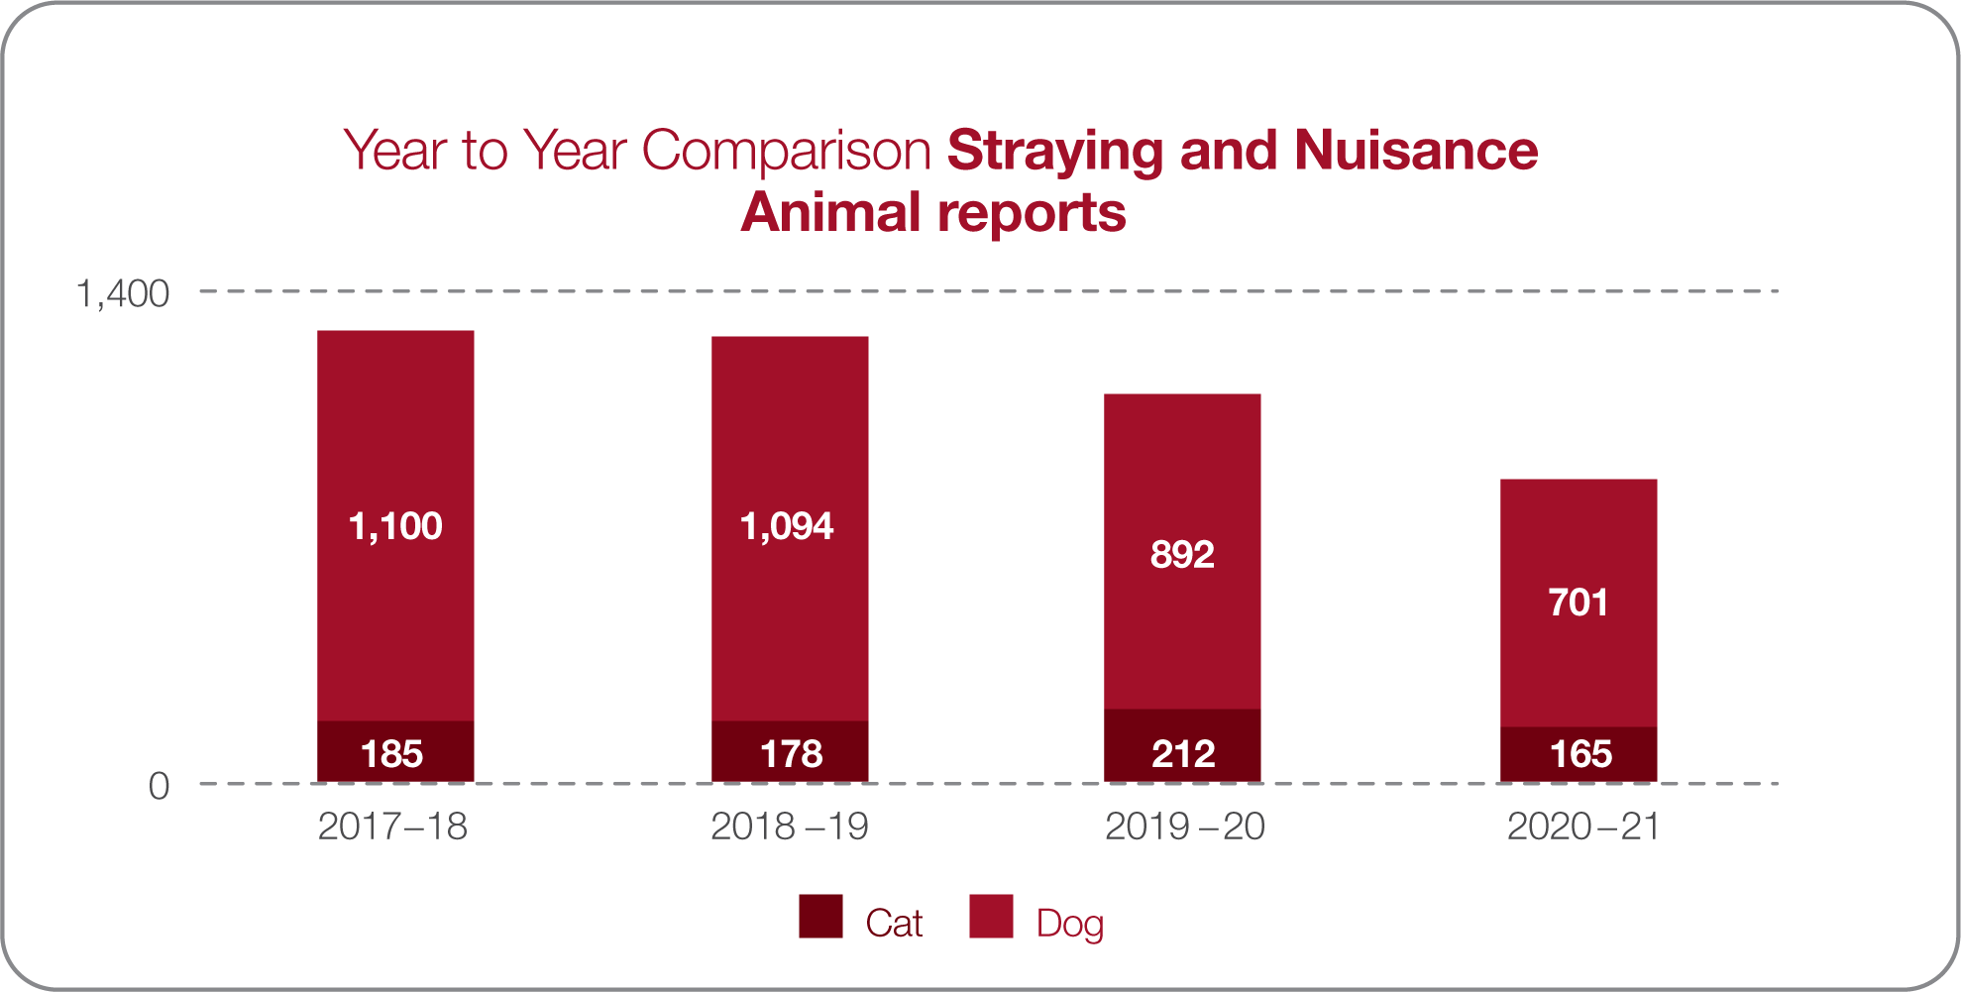

Our Orders, Local Laws, Council Policies and Procedures
Council Order and Local Law
Council Dog and Cat Order 2019 made under sections 25 and 26(2) of the Domestic Animals Act 1994 came into operation from 2020 – established dog leashing and effective control requirements, designated off leash areas, the sunset to sunrise cat containment requirement, and designated prohibited areas for cats and dogs.

General Purposes and Amenity Local Law No. 10 of 2013 – Division 1 – General Requirements
Clause 7 (1) A person using Council land or a road must comply with any conditions of use applied to that land or road by the Council and notified by way of signs e.g. dogs on lead signs
Division 3 – Animal Control
Clause 41 regulates how animals are kept to ensure amenity and prevent nuisance issues from occurring.
Clause 42 regulates the numbers of dogs and cats that can be kept at a property without a permit depending on the land size.
Clause 43 Animal Excrement – requires a dog owner to carry a litter device and collect and dispose of any animal excrement when on a road or council land.

Current Education and Promotion Activities

- Education about dealing with nuisance issues through various communication methods, including Shire Life newsletter, local papers, community newsletters, Council’s website and social media channels.
- Extensive dog on and off leash area information available on Council’s website, and printed maps at Council operated service and information centres.
- Promoting the cat trapping program.
- Providing information relating to cat containment and enrichment.
- Providing advice to owners and recommending they seek advice from professional dog trainers and animal behaviourists about dealing with nuisance issues such as barking, anxiety, and escaping.
- Encouraging the desexing of cats and dogs to reduce wandering.

Current Compliance Activities

- Investigating nuisance complaints and ensuring minimal timeframes.
- Sending out barking dog formal complaint statements and barking dog logs. Deploying barking monitoring devices to corroborate the existence of a nuisance.
- Issuing notices to comply, notices of objection and infringements where necessary.
- Periodic targeted patrols at bushland reserves and off leash areas.
- Providing cat trapping programs to residents.
- Impounding wandering dogs and working with owners to address causes.
- Providing dog poo bags in key parks and reserves.

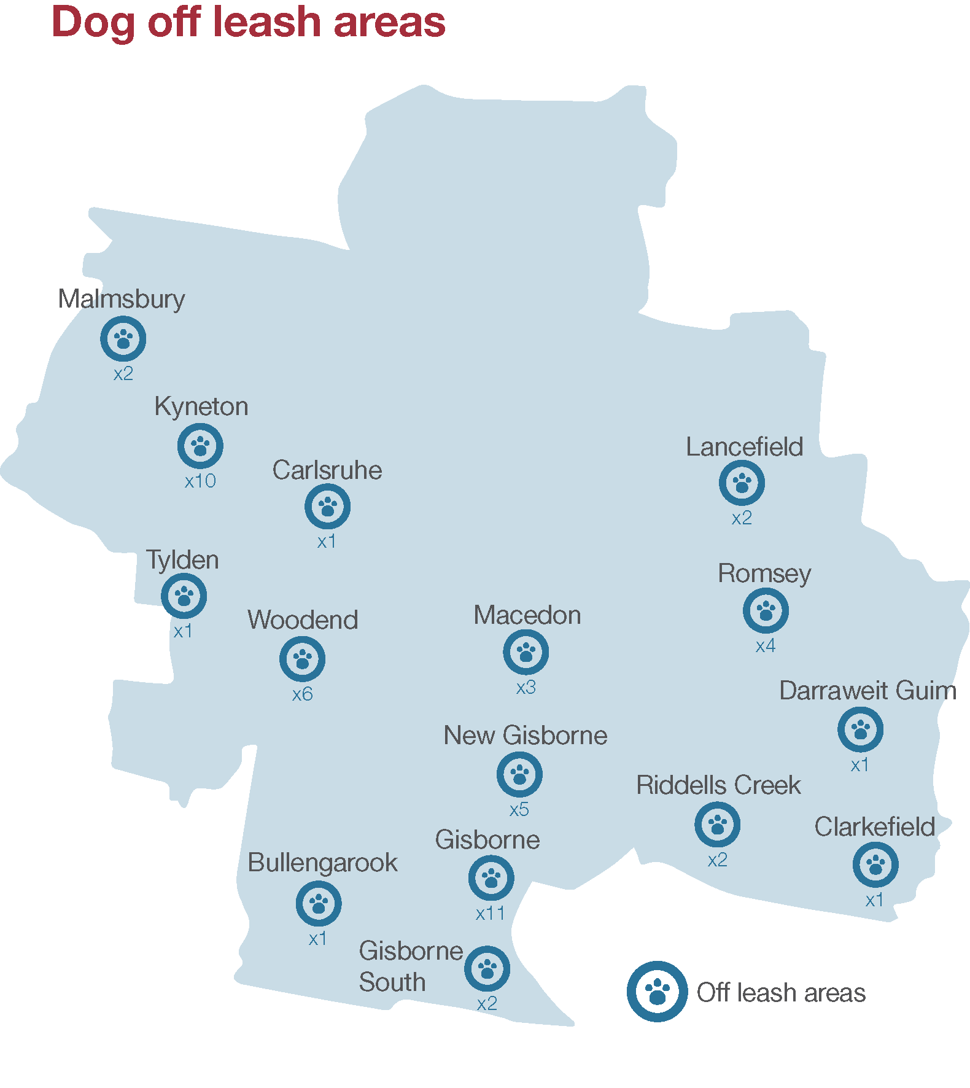

*Off leash areas include zones and walking tracks. Some of the off leash areas are subject to conditions and restrictions. Please refer to the maps and listed areas on the Council website www.mrsc.vic.gov.au/dogs in addition to signs installed at each of the off leash locations.

Summary
Council aims to reduce nuisance issues in the shire by developing a range of programs, services and initiatives that support those who have pets enjoy the benefits they bring but also support the safety and amenity of all residents.

Our Plans
Objective 1: Improve cat care and welfare to reduce nuisances and environmental impacts caused by cats.
Activity | Commence | Evaluation
Continue to raise public awareness about the benefits of containing cats for their welfare and protecting the environment. | 2022–24 | Develop and implement a dedicated communications plan aimed at educating the community about responsible cat ownership, cat containment, understanding cat behaviour, and improving cat welfare.
Promote anti-predation devices for cats (E.g. Birdsafe cat collars, cat bibs). | 2022–23 | Direct promotion to cat owners to increase use of anti-predation collar additions for cats when outdoors.
Review and update information materials for the cat trap hire program. | 2022 | Improve information materials provided with cat trap hire to ensure effective and humane use of Council provided traps.
Explore opportunities for interactive education with bushland reserve users.  (E.g. user information boards, interactive signs, QR Codes to cat information) | 2023–25 | Identify bushland reserves for targeted education about cats and the environment.
Work in partnership with industry stakeholders to develop and introduce a low cost cat desexing and microchipping program. | Ongoing from 2022 | Offer Council subsidised low-cost cat desexing and microchipping programs annually, and targeted discount vouchers throughout the year aimed at reducing feral / semi-owned cats.
Explore future expansion of the cat curfew to require 24-hour cat containment | 2024-25 | Assess the need for and effectiveness of expanding the current sunset to sunrise cat curfew to 24 hours, including consultation with the community and other Councils (who have implemented 24-hour curfews), to inform activities for inclusion in the next Domestic Animal Management Plan 2026-2030

Objective 2: Balance the needs of dog owners and the community to ensure community wellbeing, amenity and safety are enhanced. (Table continued on next page)
Activity | Commence | Evaluation
Continue to raise awareness about the Dog and Cat Control Order 2019 requirements for dogs in public places. | 2022–23 | Review and improve community signage for on leash, off leash, and effective control requirements. Patrols increased in selected areas.
Review schedules one and two of the Dog and Cat Control Order 2019. | 2022–23 | Conduct a review of designated off leash and prohibited areas – adjustments to be considered by Council for the Order
Review and update information materials for addressing dog barking nuisance. | 2022–23 | Improve information materials about Council’s barking nuisance process and self-help guidance for resolving barking issues.
Improve provisions for dogs in Council open spaces. | 2022–24 | Review off leash areas and frequently used dog walking trails to map existing dog friendly infrastructure - poo bag dispensers, bins, and dog drink stations. Identify areas of need and prioritise for future dog friendly infrastructure provisions.
Improve existing designated fenced off leash areas. | 2022–24 | Review designated off leash areas where there is existing fencing to identify and prioritise where the addition of gates or minimal fencing improvements can create secure off leash use.  Map fully enclosed off leash areas on Council’s website so dog owners can easily locate.
Implement strategies to reduce the impact of dog poo on amenity and the environment. | 2023 | Develop and implement a dedicated communications plan aimed at educating the community about responsible collection and disposal of dog poo and the impacts of dog poo on the environment.

(Table continued from previous page)
Activity | Commence | Evaluation
Explore opportunities to build purpose built dedicated dog parks. | 2023–25 | In Council’s Open Space Strategy, identify and prioritise suitable open spaces for development as purpose built dog parks.  Ensure purpose built dog parks are considered in Precinct Structure Plans.  Consider allocation of open space for purpose built dog parks in Development Plans for new estates.  Prepare plans and capital works submissions for two dog parks if suitable locations are identified.
Enhance in field education and enforcement capabilities. | 2022 - 23 | Expand mobile PinForce capabilities to issue on-the-spot warnings and infringements for animal offences.

Dog Attacks
Legislative Context – Domestic Animals Act 1994, Section 68A(2)(c)(iii) - Outline programs, services and strategies to minimise the risk of attacks by dogs on people and animals
- also addresses 68A(2)(a),(c)(i),(c)(ii),(d),(f)

Current Situation
Council Authorised officers are primarily responsible for investigating dog attacks on people and animals within Council’s jurisdiction and legislative authority. Other state authorities may have investigation responsibilities in the circumstances involving attacks related to hunting, attacks on wildlife, intentionally setting a dog to attack, or where attacks occur in State or National Parks.
Minimising the risk of dog attacks is a key priority for Council as the safety of all members of the community is paramount. Council is committed to protecting and enhancing the community safety in relation to aggressive and inappropriately behaved dogs.
Officers respond to reports relating to dog attacks/rushes and aggressive wandering dogs as a matter of urgency 24-hours a day, every day throughout the year. Dog attacks are investigated thoroughly and officers are trained to collate all evidence relating to an attack to formulate a brief, which includes obtaining statements, photographs/video evidence, DNA evidence (where required) and vet/medical reports.
Through the active promotion of responsible pet ownership and early intervention for problem dogs, Council has seen a continued reduction in the number of dog attacks over the last four years. However, dog attacks on livestock and wildlife continue to be a problem in rural areas.
There is a clear link between dogs that are not adequately secured to the owner’s property and dog attacks. The majority of attacks occur when a dog is outside its property. In most cases, owners indicate to Officers that their dog had never shown aggression before.
Responsible pet ownership practices are critical in minimising dog attacks and keeping our community safe for people and animals.
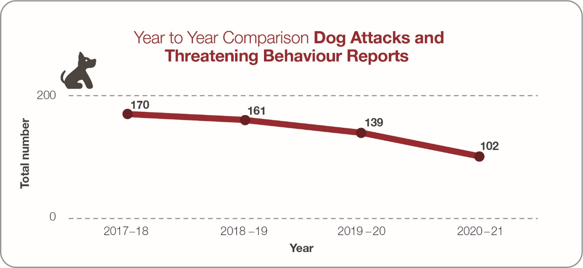

Our Orders, Local Laws, Council Policies and Procedures
Council Order and Local Law:
Council Dog and Cat Order 2019 made under sections 25 and 26(2) of the Domestic Animals Act 1994 came into operation from 2020 – establishes dog leashing and effective control requirements
General Purposes and Amenity Local Law No. 10 of 2013 – Division 3 Animal Control – Clause 42 regulates the numbers of dogs and cats that can be kept at a property without a permit depending on the land size
Council Policies and Operational Procedures – Authorised Officers prioritise dog attack responses accounting for immediate and ongoing risks, and the need to preserve evidence. Initial contact from a Local Laws team member occurs the same day of the report to triage and determine an appropriate operational response.

Current Education and Promotion Activities
- Education about minimising dog attacks through various communication methods, including Shire Life newsletter, local papers, community newsletters, council’s website and social media channels.
- Providing information at Council offices and in new resident packs.
- Promoting the effective confinement and control of dogs.
- Promoting puppy/dog socialisation and obedience training.

Current compliance activities
- Responding to all stray/wandering/unsecure dog reports throughout the Shire.
- After hours response to all reports of dogs attacking or showing aggression.
- Investigating all alleged dog attacks and rushes.
- Ensuring suspected attacking dog/s are effectively secured or seized pending investigation/prosecution outcome.
- Impounding wandering/unsecured dogs and working with owners to resolve the cause.
- Issuing warnings/infringements for wandering or unsecured dogs.
- Prosecuting and/or declaring dogs that bite or attack.
- Recording data of reported dog attacks in the municipality.

Summary
Minimising the risk of dog attacks on people and animals in the shire is a key community safety program.

Our Plans
Objective: To minimise the incidence of dog attacks in the community

Activity | Commence | Evaluation
Promote prosecution outcomes for dog attacks to act as a general deterrent. | ongoing | Work with Council’s communications team to ensure timely and broad communication of prosecution outcomes to the community.
Continue to pursue formal declarations and/or court prosecutions for dogs involved in serious or repeated instances of rushes or attacks. | ongoing | In accordance with Council’s Compliance and Enforcement Policy, take appropriate legal action to ensure community risk is reduced, specific deterrence is achieved, and that dogs involved in attacks are effectively controlled and contained.
Local Laws Officers will work directly with owners of higher risk dogs to reduce escalation of behaviours leading to dog bites/attacks. | 2023 and ongoing | Further develop and implement early intervention strategies and tools for use by Officers to directly support dog owners in addressing behavioural issues that can lead to attacks.

Dangerous, Menacing and Restricted Breed Dogs
Legislative Context – Domestic Animals Act 1994, Section 68A(2)(c)(vii) - Outline programs, services and strategies to effectively identify all dangerous dogs, menacing dogs and restricted breed dogs in that district and to ensure that those dogs are kept in compliance with this Act and the regulations.
- also addresses 68A(2)(a),(c)(i),(c)(ii),(d),(f)

Current situation
Council has five declared menacing dogs, and six declared dangerous dogs currently registered within the Shire. There are no restricted breed dogs registered.
Declared menacing dogs are those that have been declared by Council due to inflicting a non-serious bite to a person or animal, or having rushed up to a person or chased a person in an aggressive manner.
Owners of menacing dogs must abide by conditions specified by Council, being the dog is muzzled and leashed when outside the premises of its owner at all times.
Declared dangerous dogs are those that have been declared by Council due to biting or attacking and causing serious injury to an animal or person, or a dog that was declared menacing and its owner did not comply with the imposed requirements on two or more occasions. A dog that is kept for guarding non-residential premises is also defined as a dangerous dog.
Owners of dangerous dogs must abide by specific regulations in particular; secure enclosures, secure perimeter fencing for guarding dogs, warning signs on premises, wearing its prescribed dangerous dog collar at all times and being muzzled and on leash in public.
Council carefully considers whether to declare a dog menacing or dangerous. The declaration depends on the incident(s) that the dog has been involved in and the risk that the dog poses to the community. Fees for menacing and dangerous dogs are set considerably higher than other dog registration fees.

Our Orders, Local Laws, Council Policies and Procedures

Owners of dogs that are proposed to be declared menacing or dangerous are entitled to provide a written submission or appear in person to be heard by an independent panel of council officers. Terms of reference are in place to establish consistency and procedural fairness in how declaration hearings are conducted.

Current Education and Promotion Activities

- Information provided at Council offices and website.
- Liaise with dog owners relating to legislation requirements and any changes/updates.

Current compliance activities

- Investigate and respond promptly to complaints about menacing or dangerous dogs.
- Ensuring all declared dogs are registered on the Victorian Dangerous Dog Registry
- Conducting annual inspections on premises housing declared dogs to ensure compliance
- Dog declarations made where applicable
- Prosecution/Infringements issued for any determined breach

Summary
Council’s priority is to protect the community from menacing and dangerous dogs.

Our Plans
Objective: Ensure declared dogs are compliant to relevant legislation and regulations.
Activity | Commence | Evaluation
Pro-active engagement approach with owners of declared dangerous dogs to support them in meeting their legal obligations | ongoing | Continue annual audits for declared dangerous dogs as part of the registration renewal process, ensuring owners understand compliance requirements, non-compliance issues are detected and rectified, and enforcement action taken for offences.
Pro-active engagement approach with owners of declared menacing dogs to encourage behaviour modification and improve management. | 2023 | Develop incentive program for owners of declared menacing dogs to undertake a tailored behaviourist training program and management plan.

Overpopulation and high euthanasia
Legislative Context – Domestic Animals Act 1994, Section 68A(2)(c)(iv) - Outline programs, services and strategies to address any over population and high euthanasia rates for dogs and cats.
- also addresses 68A(2)(a),(c)(i),(c)(ii),(d),(f)

Current Situation
Council’s initial priority is to return all animals to their owner so they can avoid a trip to the pound. We have had great success in returning dogs home, while cats have relatively low owner return rates due to lack of identification.
Council is committed to re-homing dogs and cats that are not claimed by their owners and works with a range of partners to provide these animals with a second chance. When it is not possible to return the animal and it is not reclaimed from the pound, then all attempts are made to re-home the animal. As a result rehoming rates remain consistent, and euthanasia rates are very low. Cat re-homing rates and euthanasia rates are slowly improving.
Providing information about the benefits of desexing, microchipping, registration and containing dogs and cats are key components in reducing the numbers of unwanted cats and dogs.
Overpopulation of cats and unowned community cats continue to be of concern in the shire and are priority areas for council to address. Feedback from the consultation process confirms this with strong support from the community to introduce a council subsidised low cost desexing program for cats. However, there is less concern regarding the overpopulation of dogs in the shire. Therefore, this is not considered an issue that council needs to prioritise for dogs, except for when there are compliance/welfare issues.

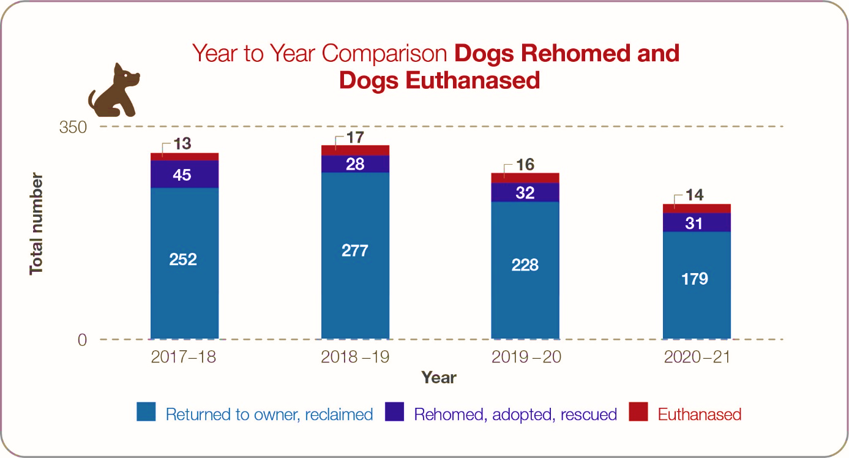

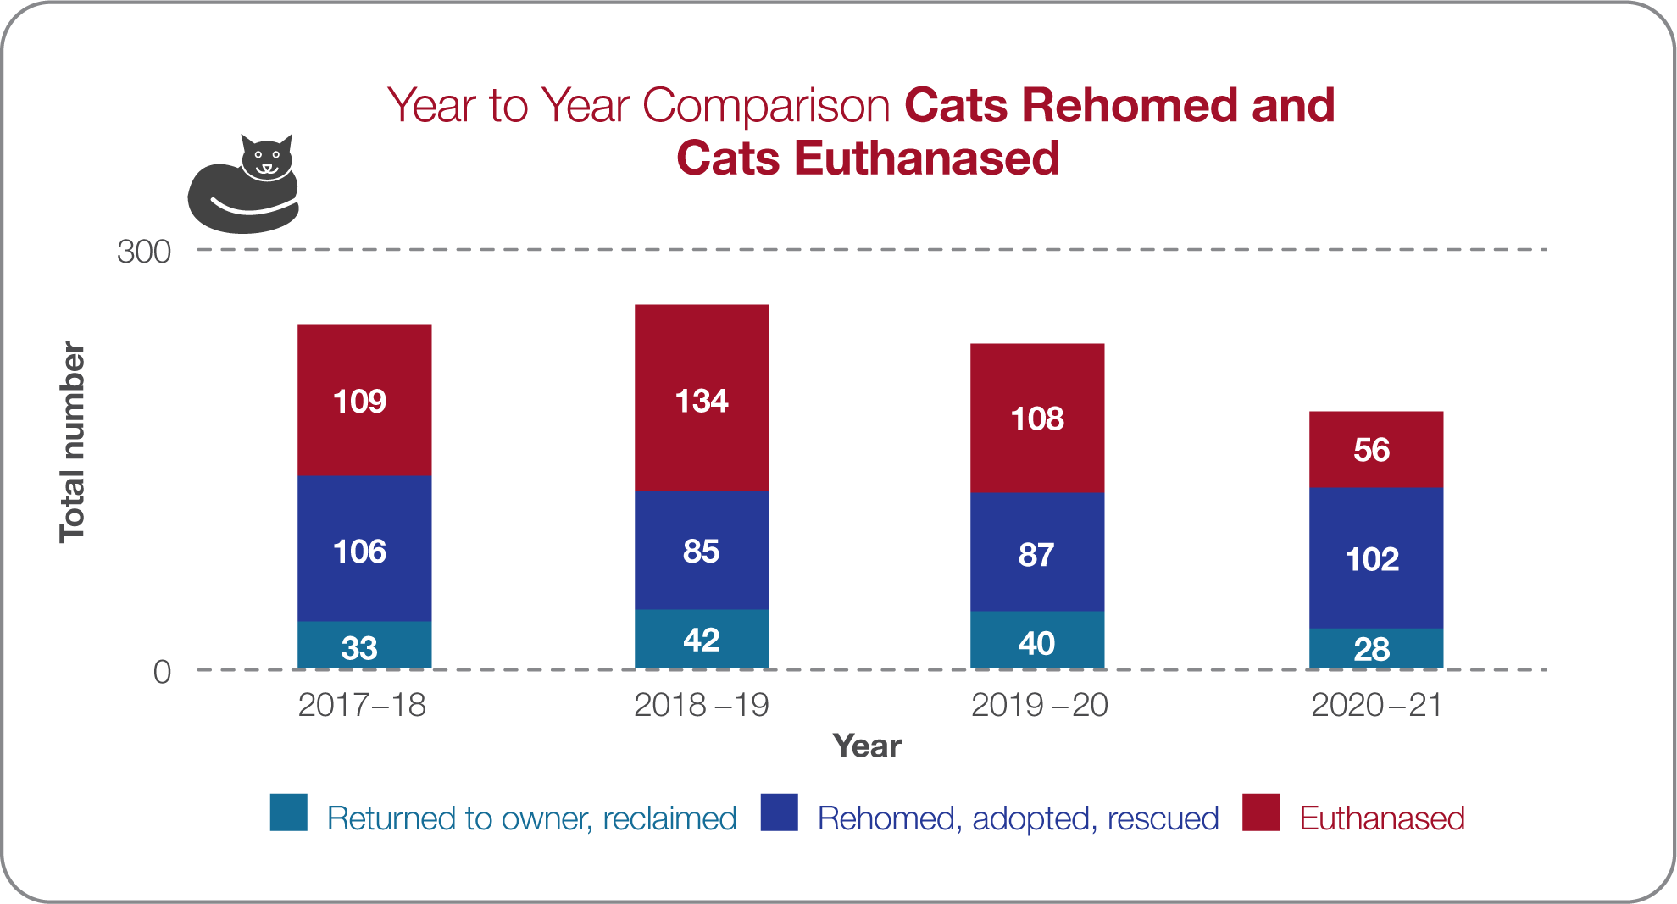

Our Orders, Local Laws, Council Policies and Procedures
Local Law
General Purposes and Amenity Local Law No. 10 of 2013 – Division 3 - Animal Control – Clause 42 regulates the numbers of dogs and cats that can be kept at a property without a permit depending on the land size.

Current Education and Promotion Activities

- Promoting benefits of desexing and encouraging through registration incentives.
- Promoting adoptions and encouraging through registration incentives.
- Promoting appropriate pet selection.
- Promoting cat containment and enrichment.
- Promote Council’s cat trapping program.

Current compliance activities

- Cat trapping program.
- Investigating unregistered breeding establishments and animal hoarding issues.
- Enforcing the Local Law relating to the number of cats/dogs on a property.
- Assessing excess animal permit applications, factoring in the number of entire/desexed animals.

Summary
Council is committed to reducing the number of unwanted cats and dogs in the community by reducing incoming numbers and improving reclaim and adoption outcomes.

Our Plans
Objective: Reduce the number of unwanted cats and dogs in the community by reducing incoming numbers and improving reclaim and adoption outcomes.
Activity | Commence | Evaluation
Work in partnership with industry stakeholders to develop and introduce a low-cost cat desexing and microchipping program. | Ongoing from 2022 | Offer Council subsidised low-cost cat desexing and microchipping programs annually, and targeted discount vouchers throughout the year aimed at reducing unwanted cats and associated impound rates.
Work with local veterinarians and pet owners to help reunite lost pets quickly. | Ongoing | Enhance partnerships with veterinary practices to aid in contacting pet owners to retrieve identifiable lost pets, and providing support to owners with addressing repeated escaping.
Continue program to prioritise reclaims and release of pets locally. | Ongoing | Officers will make every effort to identify owners to return pets home or arrange reclaim from Council facilities (conditions apply).
Ensure photos and information about stray pets impounded with Council’s pound contractor are publically available to aid owners with locating lost pets. | Ongoing | Ensure it is a condition for contracted pound services that the provider has photos of impounded pets publically available online.  Ensure Council’s lost pet information provides a link to the contractor’s impounded pet pages.

Domestic Animal Businesses
Legislative Context – Domestic Animals Act 1994, Section 68A(2)(c)(ii) - Outline programs, services and strategies which the Council intends to pursue in its municipal district to ensure that people comply with this Act, the regulations and any related legislation.
- also addresses 68A(2)(a),(c)(i),(d),(f)

Current situation

Domestic Animal Businesses (DABs) are animal shelters, pet shops, animal breeding and/or rearing establishments, boarding and/or training facilities. There are 12 registered Domestic Animal Businesses in the Shire. Registered domestic animal businesses are audited annually as well as on receipt of complaints.
Council is committed to a high standard of animal welfare and aims to ensure that all domestic animal businesses comply with relevant standards and codes. Council is also committed to identifying unregistered Domestic Animal Businesses operating within the shire and taking appropriate regulatory action to ensure compliance is achieved.
Legislative changes and the introduction of the Victorian Pet Exchange Register (PER) provide greater transparency for breeders operation in the shire. Council Authorised Officers are responsible for regulating breeding activities to ensure they are operating lawfully and must report to the Victorian Government about Domestic Animal Businesses annually.

Our Orders, Local Laws, Council Policies and Procedures

Enforcement of the legislative requirements of the Domestic Animals Act 1994 and relevant Codes of Practice.

Local Law and Planning
General Purposes and Amenity Local Law No. 10 of 2013 – Division 3 Animal Control – Clause 42 regulates the numbers of dogs and cats that can be kept at a property without a permit depending on the land size.
Planning and Environment Act 1987 and the Macedon Rages Shire Council Planning Scheme – regulates the use and development of land (including land used to keep, breed, board, or train domestic animals).

Current Education and Promotion Activities

- Providing information to registered domestic animal businesses.
- Promoting Victorian Government information and codes of practices.
- Advertising new legislation amendments.

Current compliance activities

- Annual registration of Domestic Animal Businesses.
- Annual and random auditing of Domestic Animal Businesses, both scheduled and unscheduled.
- Investigating suspected or reported unregistered domestic animal businesses.
- Liaison between Local Laws and Statutory Planning Officers to assist with permit requirements and ensure planning conditions are adhered to.
- Issuing/enforcing of infringement notices/notice to comply, or prosecuting for offences.

Summary
Council is committed to protecting the welfare of animals through working with Domestic Animal Businesses to comply with the relevant standards and effective enforcement for non-compliant businesses.

Our Plans
Objective: Ensure all domestic animal businesses are compliant with relevant legislation and codes of practice
Activity | Commence | Evaluation
Continued pro-active engagement with owners / proprietors of registered Domestic Animal Businesses to support them in meeting their legal obligations. | ongoing | Annual provision of self-audit tools for registered DABs as part of renewal process.  Regular audits by Local Laws Officers aimed at ensuring proprietors understand compliance requirements, non-compliance issues are resolved, and offences are pursued legally.
Improved surveillance and targeted enforcement activities focused on unregistered and non-compliant Domestic Animal Breeding and Rearing Businesses. | 2021–25 | Deter illegal breeding activities in the Shire through interdepartmental and interagency collaboration in permit processing, investigation, and compliance activities.  Monitor Pet Exchange Register data, dog and cat advertisements, and share intelligence with other agencies to detect illegal breeding in the Shire.
Ensure dog training establishments are registered as Domestic Animal Businesses. | 2022 | Reach out to local dog trainers and puppy pre-schools to ensure registrations are current (if required).

Other Matters – Supporting the Community in Emergencies
Legislative Context – Domestic Animals Act 1994, Section 68A(2)(e) - Provide for the review of any other matters related to the management of dogs and cats in the Council’s municipal district that it thinks is necessary

Current Situation
Council recognises the physical, mental and social benefits that pets bring and the link between enabling pet owners to keep their pets close to them or knowing that they are safe when confronted with a crisis. These situations include emergency incidents such as a house fire or bushfire, family violence or health issues. Council is committed to supporting community members through these situations by thorough emergency management planning, partnering with relevant agencies to prevent family violence and working with established networks to enable community members to remain living independently in their homes.
Council can support community members in times of crisis by working with our partners to coordinate the transport of animals, temporary boarding of animals and veterinary care if required. We know that by doing this residents can focus on other important issues knowing that their pet is safe.
Council has an Emergency Animal Plan that may be enacted in larger emergencies that helps residents and emergency personnel manage pets and livestock.
Council can temporarily accommodate pets at Emergency Relief Centres, and Local Laws officers are trained to assist residents and their pets at these centres. In addition, the council has programs in place to assist vulnerable members of the community with their pets when experiencing family violence or other personal crises.

Our Orders, Local Laws, Council Policies and Procedures

Emergency Animal Plan is a sub-plan of the Municipal Emergency Management Plan.

Current Education and Promotion Activities

Council provides education and promotion about including pets in personal fire plans through various communication methods such as Shire Life newsletter, local papers, community newsletters, council’s website and social media channels.

Summary
Council is committed to providing support to community members in times of need so that their pets are safe and well cared for.

Our Plans
Objective: Support community members who in times of need require assistance in providing care for their pets
Activity | Commence | Evaluation
Continue to support vulnerable members of the community with temporary animal boarding and care. | ongoing | Provide individualised support and/or facilitate temporary boarding for animals to assist pet owners experiencing an emergency, personal crisis, or family violence situation (single incident).
Building emergency preparedness – planning for pets in emergencies | 2023 - 2024 | Develop a communications plan aimed at building community capabilities to plan for pets in emergencies.
Review Council’s Emergency Animal Plan | 2023 | Review and update Council’s Emergency Animal Plan to ensure pet owners are supported during emergency events.

Other Matters – Promoting Council’s Animal Services
Legislative Context – Domestic Animals Act 1994, Section 68A(2)(e) - Provide for the review of any other matters related to the management of dogs and cats in the Council’s municipal district that it thinks is necessary

Our Orders, Local Laws, Council Policies and Procedures

Council does not currently have any policies or communication plans specifically promoting responsible animal ownership and Council’s animal services in the community.

Current Education and Promotion Activities

Education and promotion about responsible animal ownership and services are done on an ad-hoc basis without an over-arching communications plan to drive behaviour change. Communications are currently done through the Shire Life newsletter, local papers, community newsletters, Council’s website and social media channels. Local Laws Officers also do direct education with residents and pet owners through service interactions. However, feedback indicates there is a lack of information available through Council, leading to a lack of knowledge, or in some cases a misunderstanding, about animal services provided.

Summary
Through improved communications to the community, Council has an opportunity to increase transparency about its animal services, enhance Council’s reputation in leading good animal welfare and management practices, and improve responsible pet ownership outcomes.

Our Plans
Objective: Improve Council’s public education and communications about responsible animal ownership and animal services
Activity | Commence | Evaluation
Raise community awareness about Council’s animal services, responsible pet ownership, pet behaviour, and animal welfare. | 2022–25 | Develop and implement a dedicated pet communications plan with regular and consistent messaging using a variety of platforms and methods shown to drive behaviour change. Ensure a variety of mediums to enable broad community reach.

Annual Review of Plan and Annual Reporting
Legislative Context – Domestic Animals Act 1994, Section 68A(3) Every Council must—
- review its domestic animal management plan annually and, if appropriate, amend the plan
- provide the Department of Economic Development, Jobs, Transport and Resources Secretary with a copy of the plan and any amendments to the plan
- publish an evaluation of its implementation of the plan in its annual report.

Our Plans
Objective: Review the Domestic Animal Management Plan to ensure it is current and meets the needs of the community
Activity | Commence | Evaluation
Review the plan annually and amend where necessary | Annually | Annual review conducted and amendments made where necessary.
Include information in the council annual report about activities implemented | Annually | Information included in annual report

Appendix 1 – General Purpose and Amenity Local Law No. 10 of 2013

Division 1 – General Requirements
7. General Requirements applying to the use of Council Land and Roads
- A person using Council land or a road must comply with any conditions of use applied to that land or road by the Council and notified by way of signs, conditions of entry or conditions of membership.

Division 3 – Animal Control
41. Keeping Animals
- A person keeping animals on land must not allow any animal to:
- cause a nuisance to any other person because of noise, smell or any other condition;
- damage any flora or fauna on the land;
- pollute any drain, gutter, watercourse or water catchment on or through that land; or
- cause the invasion or spread of noxious or environmental weeds on or from that land.

Penalty: 10 Penalty Units

- A person providing housing for animals kept on land must ensure that a nuisance or offensive condition is not caused to adjoining land and that:
- animal housing is:
(i) constructed and maintained to the satisfaction of the Authorised Officer;
(ii) kept clean and sanitary at all times;
(iii) located at a distance from dwellings on other land to the satisfaction of the Authorised Officer;
(iv) located at a distance from any property boundary to the satisfaction of the Authorised Officer;
- food is kept in fly and vermin proof buildings or containers other than baled, rolled, sheaf hay or silage; and
- the land is kept free of materials, refuse and vegetation that may harbour or attract rats, mice or other vermin.

Penalty: 10 Penalty Units

- A person must not feed or encourage the presence of feral, stray or pest animals or allow such animals access to food on the land on which animals are kept.

Penalty: 5 Penalty Units
42. Limits on Numbers of Animals
- A person must obtain a permit to keep animals in excess of the numbers permitted or to keep animals on land less than the area prescribed as follows:

Dogs and cats
- On land up to 4,000 square metres (1 acre) - 2 dogs and 2 cats
- On land greater than 4,000 square metres (1 acre) - 4 dogs and 4 cats.

Roosters
- Less than 4,000 square metres (1 acre) - 0.

Pigs or piglets
- Less than 10,000 square metres (2.5 acres) – 0.

Farm animals
- Less than 2,000 square metres (0.5acre) – 0 unless sub-clause (2)(c) applies.

Penalty: 20 Penalty Units
- The requirement to obtain a permit under sub-clause (1) does not apply if:
- the number of animals to be kept on land is because of a commercial undertaking on the land and the use is authorised under the Planning Scheme or a permit has been obtained under the Planning Scheme;
- the dogs are kept for working stock on farm land which is greater than 40 hectares; or
- farm animals are on the land for not more than 1 month and are being used for fire prevention or weed management purposes.

43. Animal Excrement
- A person in charge of an animal must not allow any part of that animal’s excrement to remain on any road or Council land and must immediately collect and dispose of the excrement.

Penalty: 10 Penalty Units

- A person in charge of an animal on any road or Council land must carry sufficient litter devices to collect and dispose of animal excrement and must produce them on request to an Authorised Officer.

Penalty: 5 Penalty Units

44. Effective fencing and confinement of farm animals
- An owner or occupier of land must ensure that the land on which a farm animal is kept is adequately fenced or confined in a satisfactory condition to ensure that the type of farm animal kept on the land cannot escape from it.

Penalty: 10 Penalty Units

- If a farm animal is found at large outside the land of the owner or not securely confined to the owner’s land between sunrise and sunset, the owner is guilty of an offence.

Penalty: between sunrise and sunset - 10 Penalty Units

- If a farm animal is found at large outside the land of the owner or not securely confined to the owner’s land between sunset and sunrise, the owner is guilty of an offence.

Penalty: between sunset and sunrise - 20 Penalty Units

