Community Engagement Policy

Date of Adoption | 22 June 2022
Adoption Method | Council | CEO |  | Other (please specify)
CEO Signature |  |  |  |  | Date
Responsible Officer and Unit | Coordinator Communications and Engagement, Communications and Engagement Unit
Nominated Review Period | Annually |  | Every 4 years
Last Endorsement Date | 27 January 2021
Next Endorsement Date | June 2026

Macedon Ranges Shire Council acknowledges the Dja Dja Wurrung, Taungurung and Wurundjeri Woi Wurrung Peoples as the Traditional Owners and Custodians of this land and waterways. Council recognises their living cultures and ongoing connection to Country and pays respect to their Elders past, present and emerging.
Council also acknowledges local Aboriginal and/or Torres Strait Islander residents of Macedon Ranges for their ongoing contribution to the diverse culture of our community.

Contents

Introduction 3
Policy statement 3
Purpose 3
How this policy was developed 3
Definition of engagement 4
Definition of deliberative engagement 5
Why we engage 5
When we will engage 5
Who we will engage 6
Principles and actions 7
Roles and responsibilities 8
Making a decision 9
APPENDIX 1: Definitions 10
APPENDIX 2: Statutory consultation 12
APPENDIX 3: References, Related policies, Related legislation 14

Introduction

This Community Engagement (CE) Policy was developed with input from the community, Councillors and staff. It builds upon Council’s CE Policy developed in 2020 and adopted in 2021.

Policy statement

Macedon Ranges Shire Council commits to lead, promote and advocate for meaningful community engagement. Effective planning and resourcing of community engagement helps to ensure high standards of transparency and accountability in Council’s decision-making processes.

Our engagement will align to the Council Plan strategic objectives and priorities. Council values the contribution our community can make to shaping a strong future that connects communities, supports a healthy environment and people, enhances business and tourism and delivers strong and reliable government.

Purpose

This Community Engagement Policy documents Macedon Ranges Shire Council’s commitment to community engagement planning, delivery and evaluation. It provides clarity of intent and informs the community of why, when and who we engage.

It outlines the principles that guide our work and our actions to address these. It articulates our shared responsibility so that we are all clear of our roles and contributions.

The Policy ensures Council is accountable to the community it serves including our ratepayers, residents, business owners and visitors. It aims to enhance our relationship with our community and strengthen the dialogue and shared problem solving.

How this policy was developed

This policy was developed in consultation with the community, Council and our employees. Initially adopted in January 2021 the Policy was reviewed in early 2022 and amended to reflect the community and Council feedback.

Council will review this policy and our engagement processes every four years to ensure that it continues to reflect the expectations of the community, Councillors and staff.

Definition of engagement

Community engagement is a planned process with the specific purpose of working with individuals and groups to encourage active involvement in decisions that affect them or are of interest to them.
Council’s community engagement activities result in better decisions that aim to improve policies, services and facilities, as well as supporting greater community satisfaction and wellbeing.

Where there is no decision to be made Council will be transparent that this process is an information exchange and may not lead to changes and/or directly result in action.

The International Association for Public Participation (IAP2) Spectrum is one of the tools used to identify the need for, and level of engagement required.

Table 1: IAP2 Spectrum of Public Participation (2018) adapted by Council to include the community role and relevant engagement examples.

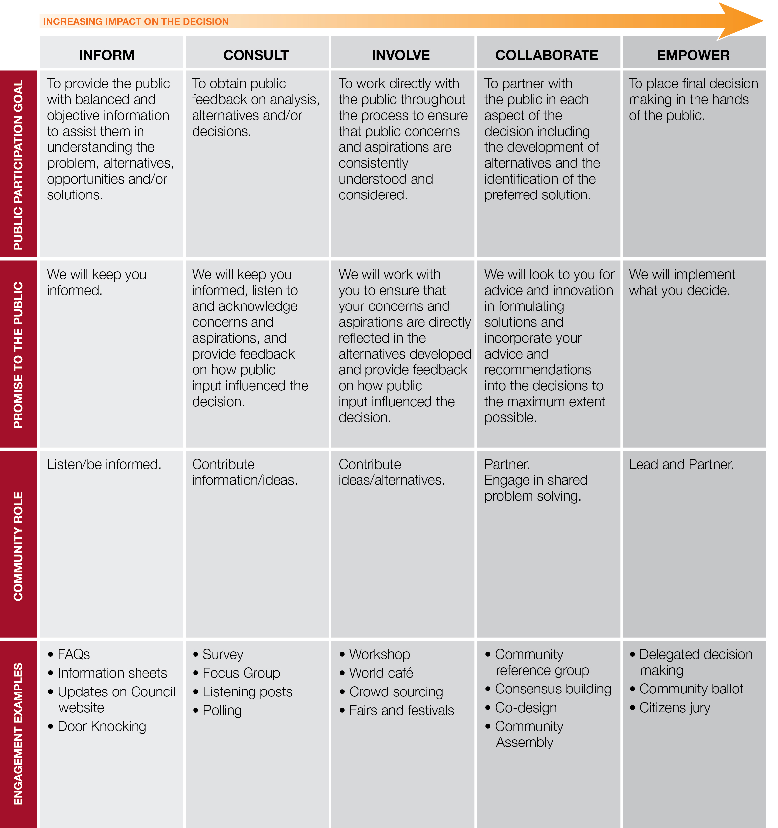

Definition of deliberative engagement

Deliberative engagement methods are applied to complex issues that require multiple perspectives and deep thinking to arrive at shared outcomes. Typically, deliberative engagement will involve a randomised group that broadly represents the community at large. It will take place over time and require the provision and development of quality information. Access to specialists and technical experts is required to deepen the understanding of the opportunities and constraints of the topic at hand. Participants are supported to hold dialogue and deliberate before arriving at consensus-based recommendations and/or decisions.

Council will undertake deliberative engagement on its:
- Community Vision
- Council Plan
- Asset Plan
- Financial Plan
Other projects may involve a deliberative process where Council determines this is the best-fit approach. Refer to Appendix 1 for a full list of definitions.

Why we engage

Council acknowledges that the community has a wealth of knowledge and experience that when shared can result in best practice policy, program, and service outcomes. Obtaining wider perspectives on an issue can open new opportunities and bring innovation and new and creative ways of doing things.

The process of community engagement can build community capacity, enhance trust and foster a sense of united purpose. It can enhance relationships, partnerships and attract investment.
Good democratic governance occurs when Council has the commitment and resources to effectively inform and engage its community in the planning and delivery of Council activities prior to a decision being made.

When we will engage

In determining the need for community engagement Council considers both its statutory requirements as well as determining how engagement could enhance the outcomes of a particular policy, plan or project. Statutory engagement processes are prescribed by the State Government; however, this does not prevent Council undertaking additional engagement if the issue warrants it.
For specific issues requiring statutory consultation and planning scheme amendments, see Appendix 2.

Each non-statutory topic will be considered for its engagement opportunity and an assessment made of the complexity to determine the engagement level. This stage will include consideration of the timeframes and what resources are required to plan, deliver and evaluate the engagement.

Who we will engage

Some of our decisions affect the entire community, while other decisions affect some people more than others. It is our duty to identify and engage with those who are impacted and interested, including those who may face barriers to engagement.

Sometimes the issue will require us to engage with other levels of government, peak bodies, and community organisations. Many of these peak bodies and community organisations can support the engagement process by advocating for participation and helping to recruit participants.
The Local Government Act section 56 states, ‘Participants in community engagement must be representative of the persons and groups affected by the matter that is the subject of the community engagement’. To this end Council aims to harness the views and involvement of a diverse community through the engagement design and delivery of appropriate messaging and methods.

Examples of our stakeholder groups:
- Aboriginal and Torres Strait Islander people
- LGBTQI community
- Children and young people
- Young parents
- Cyclists (both professional and leisure)
- Students
- Visitors
- Older people
- Town based groups
- People with disabilities
- Heritage and history groups
- Culturally and linguistically diverse groups
- People working in specific professions or industries
- Families
- Ratepayers (resident and non-residents)
- Sports and recreation clubs
- People experiencing financial hardship
- Park and or trail users
- Traditional owners
- Small businesses
- Tourism providers

Principles and actions

The Local Government Act 2020 establishes five community engagement principles applicable to Council. This Policy gives effect to these principles.

Table 1: Principles and actions
Principle | Action
- A community engagement process must have a clearly defined objective and scope. | Each engagement activity will be supported by a community engagement plan that identifies the purpose, objectives, stakeholder assessment, methods and measures for success.  Adequate and appropriate resources will be made available to ensure effective practice.
- Participants in community engagement must have access to objective, relevant and timely information to inform their participation. | Information to support the engagement will be made available in an accessible and timely manner.  Opportunities will be made available to ask questions and seek clarification.  Deliberative processes will include the opportunity for community members to liaise, learn, share information, and have informed deliberations.
- Participants in community engagement must be representative of the persons and groups affected by the matter that is the subject of the community engagement. | Each engagement plan will include a thorough stakeholder assessment and where required, a risk analysis.  The Victorian Government’s Gender Impact Assessment Toolkit will help to guide the stakeholder assessment and methods in recognition a person may experience disadvantage based on Aboriginality, age, disability, ethnicity, gender identity, race, religion, sexual orientation and other attributes.  The Commission for Children and Young People’s Child Safe Standards will also help guide the stakeholder assessment and engagement methods, with a focus on Child Safe Standard 7: Strategies to promote the participation and empowerment of children. This is in recognition that children have a right to be heard and have their concerns and ideas taken seriously, particularly on matters that affect them.  Communication methods and promotion will be tailored to suit the targeted audiences.  Diverse communities will be encouraged to participate including those that identify as a minority, either culturally, socially or linguistically.
- Participants in community engagement are entitled to reasonable support to enable meaningful and informed engagement. | Communication tools will include information formats to support participation including language, graphics, and a range of accessible requirements.  Methods will be delivered in a range of formats to suit the issue i.e., face to face and online and include a variety of times and locations.
- Participants in community engagement are informed of the ways in which the community engagement process will influence Council decision making. | The IAP2 Spectrum assessment will guide the level of influence and promise in any given engagement program.  Issues within the sphere of influence by the community will be clearly communicated at the outset.  Those things outside of community influence will be explained and a rationale provided.  Where engagement is community led, the level of influence and commitment is still articulated.  Community engagement plans will be flexible and can be adjusted as required.  Community engagement outcomes (including the extent to which the engaged informed the decision) will be shared in a variety of ways with the broader community.

Roles and responsibilities

Table 2: Roles and responsibilities
Role | Responsibility
Mayor and Councillors | - Champion the principles of quality engagement through demonstrating leadership and modelling good practice  - Stay informed of engagement activity  - Attend engagement activity as appropriate  - Consider community engagement feedback as part of the decision-making process
CEO and Senior Leadership team | - Advocate for and model a culture of good practice engagement  - Ensure adequate resourcing of engagement  - Communicate cross organisationally
Managers and Coordinators | - Manage teams and workflow  - Ensure appropriate team members are trained and supported  - Develop and provide information  - Report engagement findings and evaluation
Team members | - Develop community engagement plans and implement in a consistent way that gives effect to the Council Plan and the CE Policy  - Evaluate engagement processes  - Report engagement findings and evaluation
Advisory Committees and Reference Groups | - Advocate for quality community engagement and increased participation  - Contribute ideas  - Seek out ideas of other community members
External consultants | - Advocate for quality community engagement and increased participation  - Act in accordance with the CE Policy
Community stakeholders, groups and individuals | - Become informed about the role of Local Government  - Participate in an active way by seeking out and requesting information  - Contribute and share ideas  - Advocate for quality community engagement  - Be respectful of others’ ideas and opinions

Making a decision

Following a planned community engagement activity Council will:
- Consider the engagement report
- Consider the feedback in the context of who was engaged, other data, advice, strategies and/or legislation that is relevant in the matter.

The community will be notified of the report going to Council and the agenda made public.

APPENDIX 1: Definitions

Term | Definition
Co-design | A partnership with community to come to an agreed model or design of service delivery or public infrastructure. Can also refer to the co-design of the engagement process itself to ensure it is fully transparent and works for all parties.
Community | Can refer to the Macedon Ranges Shire community as a whole or:  - community of place (based on geographic location e.g. the Gisborne community)  - community of practice (based on common interests and activities e.g. the bike riding or gardening community)  - community of identity (based on an individual’s shared perspective e.g. Aboriginal heritage, language speakers, residents of public housing, particular age groups or a religious community)
Community engagement | Involving those affected by or interested in a decision in the decision-making process.
Deliberative elements | Used where time and resources required of a full deliberative exercise is incompatible with the level of impact a decision entails, but the impact is sufficiently high or the decision is sufficiently complex to still warrant an extra level of transparency, meaningfulness and representation. Examples of elements of deliberative practice include:  - Inviting a representative sample of those impacted by a decision in to a one-off workshop in order to hear the range of perspectives and share more detailed information (this would usually happen after a broader community consultation so the full range of perspectives and issues requiring compromise are fully understood)  - Inviting the community to consider the trade-offs involved in decision by presenting options, choices or a budget framework  - Offering information sessions and accessible explanations of the project scope where issues are complex or dependent on other factors  - Inviting key stakeholders or a sample of those highly impacted to co-design the engagement process to ensure it reaches out to the right groups and is fully representative.
Deliberative processes and/or citizens juries | Usually convened for more complex, long term and high impact issues, where perspectives are likely to differ and/or where the issue is high impact on sections of the community. Can take different forms but best practice always involves:  - a representative sample of the population or group who are impacted  - a clear scope and remit that often asks for an agreed compromise of interests and outcomes, agreed priorities or consensus on a vision and direction  - provision of timely, objective and independently sourced/verified information  - sufficient time  - support to participate (including independent facilitation, reimbursement for time, hardships and expenses incurred)  - a commitment to participants on the level of influence their recommendation or decision holds
Engagement approach | The design/plan that ensures appropriate timing, resources, tools and methods according to a considered analysis of those affected, impacted or interested and the scope and remit of any engagement project.
Representative community panel | Can be used to deliver a range of engagement types from world café’s, in person and/or online advisory groups through to complex deliberative processes. Panels can provide a representative sample of the population (to acceptable industry standards) of Macedon Ranges and can be appropriate for whole of Council area decisions with wide reaching impact. Panels can also provide representative samples for niche decisions impacting particular groups of the Macedon Ranges community but still require appropriate support, time and information.
Stakeholders | Sections of the community involved in engagement because of impact, interest or responsibility to deliver on an outcome. Can also refer to external organisations, and other levels of government involved in a decision. Always includes internal decision makers and implementers of decision outcomes.
Tools and methods | Refers to the many types of engagement that can be employed such as online or in person, public meetings and community panels, surveys, ideas boards, public competitions or deliberative budgeting for example.

APPENDIX 2: Statutory consultation

While the community engagement processes used for the matters below will vary according to the complexity of the particular issue, each process used will include consideration of any submissions received as part of any statutory community consultation under applicable legislation.

Council has responsibilities and makes decisions under a wide variety of Victorian and Australian legislation. In many instances the legislation sets standards and provides minimum requirements in regard to notifications and referrals. This includes the following matters:
- Setting Councillor and Mayoral allowances (s 39)
- Adopting a Council Plan
- Making and amending a Local Law (s 73)
- Changing the Council’s system of land valuations for Council rates (s 355)
- Adopting a budget
- Declaring a special rate or a special charge
- Selling, exchanging or leasing land
- Entering into a regional library agreement
- Deviating or discontinuing a road
- Developing or amending Governance Rules (s 60)
- Leasing land not included as a proposal in the budget (s 114)
- Conducting a review of, or restructuring advisory panel (s 16 & s 239)

The statutory consultation required by law for these matters may include all or some of the following:
- The Council must publish a public notice (in a local or daily newspaper, and on the Council‘s internet website) that identifies the proposal and tells people that they have the right to make a written submission to the Council.
- People who wish to make submissions must lodge them by the date specified in the public notice
- Anyone who has made a written submission and asked to be heard in support of this submission is entitled to speak to the Council or a committee appointed for the purpose. The submitter may appear in person or be represented by someone else.
- The Council must fix a time, date and place for this meeting and give reasonable notice of the meeting to each person requesting to be heard.
- The Council or a Council committee must consider any submissions received before making a decision.
- After it has made a decision, the Council must write to a person who has lodged a submission advising of the Council decision and the reasons for it.

Planning scheme amendments
Specific consultation arrangements apply in relation to proposed amendments to the Planning Scheme under the Planning and Environment Act 1987. These arrangements enable a person to make a submission:
- to the planning authority about an amendment to its planning scheme
- to a panel appointed to consider a planning scheme amendment.

Council is required to give public notice when proposing amendments to its Planning Scheme, including advice about how submissions can be made.

Protocol for planning permits
In considering with any planning application, Council complies with its statutory consultation obligations which can include the following consultative protocol:
- Letters to adjoining landowners and occupiers and a sign being required to be placed on the site. In some instances in addition to the letters and sign on-site, public advertising of the proposal will occur in the local newspaper(s).
- Notifications to surrounding residents/landowners will advise people on how they can view any plans and supporting information on a proposal. In such instances the information will be available at the relevant Council service centres and online.
- In some circumstances where high levels of community interest are anticipated, community information sessions can be held, either by the developer alone or jointly with Council.
- All submissions on a proposal will be considered in determining any application. If there are objections, the planning officer may convene and facilitate an applicant/objector(s) meeting.

APPENDIX 3: References, Related policies, Related legislation

References

This policy is informed by a range of external research and best practice standards, including:
- Public Participation in Government Decision Making – Victorian Auditor General’s Office – better practice guide
- International Association for Public Participation www.iap2.org (IAP2) Quality assurance standards – Core Values, Practitioners Code of Ethics and the IAP2 Spectrum of Public Participation
- Co-design Community Engagement, Victorian Government

Related Policies

- Governance Rules
- Part II Statement
- Councillor Code of Conduct
- Staff Code of Conduct
- Complaints Policy
- Live Streaming and Publishing Recordings of Meetings Policy
- Public Transparency Policy
- Privacy Policy
- Procurement Policy

Related Legislation

Local Government Act 2020 (Vic)
Local Government Act 1989 (Vic)
Freedom of Information Act 1982 (Vic)
Privacy and Data Protection Act 2014 (Vic)
Health Records Act 2001 (Vic)
Charter of Human Rights and Responsibilities Act 2006 (Vic)
Equal Opportunity Act 2010 (Vic)
Public Records Act 1973 (Vic)
Privacy Act 1988 (Cth)
Copyright Act 1968 (Cth)
Other relevant legislative instruments

