‘disaster is no excuse for family violence…’ materials
The Prevention of Violence Against Women in Emergencies Subcommittee of the Macedon Ranges Municipal Emergency Management Planning Committee has produced a suite of materials to raise awareness of the probability of increased family violence after natural disasters and to provide information on where people can find help and support.

The ‘disaster is no excuse for family violence…’ poster text was based on a postcard produced by the GAD Pod; further developed by the Subcommittee; and reviewed by our Expert Panel. The designed poster was reviewed by the Macedon Ranges Family Violence Network and tested with Council staff.

An accompanying DL flyer and wallet card was also produced. These materials will be used after an incident in relief and recovery centres and other locations in the affected district.

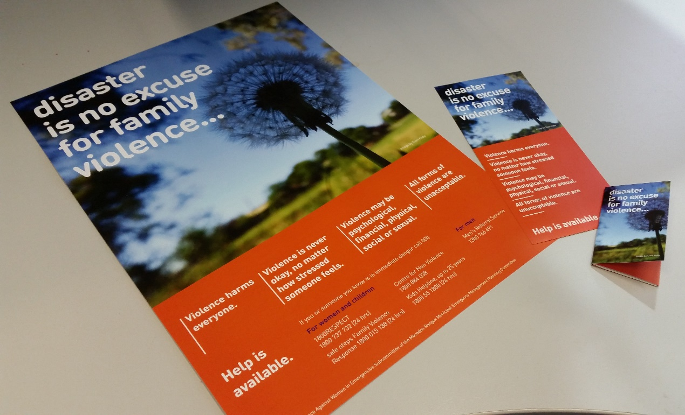

Generic wallet card
In response to feedback received from stakeholders, the Subcommittee also produced the ‘there is no excuse for family violence…’ wallet card to meet demand for a generic wallet card as the ‘disaster is no excuse...’ card is only intended for use after an emergency incident.

These wallet cards replace the ‘breaking the silence’ wallet card produced a couple of years ago – the content has been reviewed and the design refreshed. We will send copies of the cards to libraries, Council service centres, MCH Centres, medical centres, community health agencies, the hospital, kindergartens, police stations, neighbourhood houses and other locations upon request.

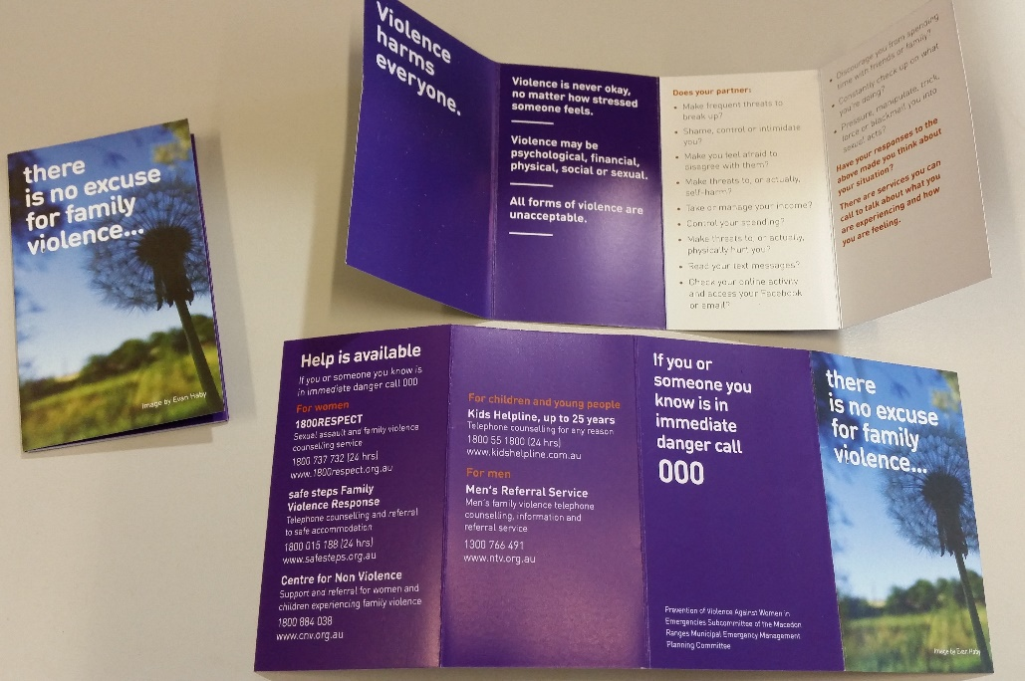

Enquiries: Kerry Haby on 5422 0260 or khaby@mrsc.vic.gov.au

