Frequently Asked Questions: Heritage Overlay

- Why protect heritage?
Heritage places enrich peoples’ lives, often providing a deep and inspirational sense of connection to the community. They are historical records telling us about who we are and the past that shaped us. They are an everyday reminder linking our past with our future. The Shire’s heritage buildings and places contribute substantially to its unique visual character and are a significant factor in making Macedon Ranges a special place to live and to visit.
Council applies the Heritage Overlay to conserve and enhance heritage places and to ensure that any development does not adversely affect the significance of a heritage place.

- What is the Heritage Overlay?
The Heritage Overlay is a planning control contained within the Macedon Ranges Planning Scheme (Clause 43.01). The control is applied to either individual heritage places (usually buildings but sometimes other structures, trees or gardens) or heritage precincts.
A heritage place may be privately or publicly owned. It may have aesthetic, archaeological, architectural, cultural, scientific or social values associated with its history.

- How does the Heritage Overlay work?
New works to those places within the Heritage Overlay require a planning permit to ensure that the works are appropriate and do not adversely affect the significance of the place.

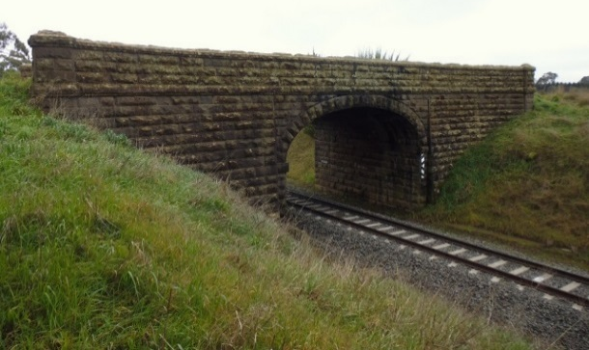
- Does inclusion of the Heritage Overlay mean I can’t do anything to my building?
No, on the contrary. You are encouraged to maintain your building and the household or business activity within it. The intention of the Heritage Overlay is to ‘conserve and enhance’, not to create museums or to inhibit the continued use of heritage places. Some sensitivity is required where change is required and the Heritage Advisor can assist as a free service.

- Will my building/property lose value when it is listed on the Heritage Overlay?
There is no evidence that heritage listing causes a decrease in value. Many people look for a building with historic character for their home or business. A lack of maintenance is more likely to decrease a property’s value than heritage listing.

- Are my insurance premiums likely to go up as a result of my building being included on the Heritage Overlay?
No, not specifically. Individual insurers may vary but there is no requirement under the Overlay to rebuild a replica of the building should the original be destroyed.

- Can I extend my heritage building?
Yes, but sensitively. The extension should be located and designed to not intrude upon the appreciation of the heritage building. Extensions need not be designed to replicate the original – in fact, a simple contemporary addition is usually better. Vertical extensions to the existing building are usually discouraged. The Heritage Advisor can provide advice on suitable approaches.

- Is it only the outside of the building which is included on the Heritage Overlay?
Sometimes, but not always. In many cases it is just the outside, while in some cases the Schedule to the Heritage Overlay includes controls that apply to external painting, internal alterations, and trees, and whether alterations to outbuildings and fences are exempt from notice and review requirements. The reference document’s citation for the individual place includes a specific Statement of Significance describing what elements of the place are important and may include guidelines for managing the preservation and enhancement of specific elements.

- Do I have to paint my building in heritage colours?
It is encouraged, but rarely mandatory, that an original colour scheme is used. A sensitive, but not strictly authentic, colour scheme may also be appropriate. Painting of exposed masonry is prohibited in some cases.

- What does the application of controls on an interim basis involve?
The Minister for Planning can introduce an amendment to apply heritage planning controls on an interim basis. Usually this is in order to protect places for a period while permanent controls are going through a normal council-led process including public exhibition. In most cases the interim controls are the same as those that are proposed to be applied permanently. Unlike the permanent controls, the interim controls have an expiry date and are not open to submissions from property owners or the general public.

- Where can I get further information?
It is important that any property owner who is affected by an existing or proposed Heritage Overlay contact Council’s Heritage Advisor prior to undertaking building or works on their property. This is a free service for advice about permits, appropriate maintenance and what sort of modifications may improve rather than detract from a heritage property. Appointments can be made through Statutory Planning on 5421 9676.

If you have queries about the process of applying the Heritage Overlay through a Planning Scheme Amendment, please call Philip Schier in Strategic Planning on 5421 9505.

